Compensation and Pension Record Interchange (CAPRI)

System Administration
and
Technical Guide



June 2012

Version 1.0

Department of Veterans Affairs (VA)
Office of Information and Technology (OIT)
Management & Financial Systems

Revision History
Date | Version | Description | Author
7/10/2012 | 1.0 | Initial Publication | Eileen Fairbrother / Mike Jenkins / Donna Sandusky / George Kocis / Susan Koch

Preface
Purpose of the System Administration and Technical Guide
The System Administration and Technical Guide document describes the handling, functionality and architecture of the CAPRI product. The guide includes detailed information about the technical architecture and components associated with CAPRI.
Reference Numbering System
This document uses a numbering system to organize its topics into sections and show the reader how these topics relate to each other. For example, section 1.3 means this is the main topic for the third section of Chapter 1. If there were two subsections to this topic, they would be numbered 1.3.1 and 1.3.2. A section numbered 2.3.5.4.7 would be the seventh subsection of the fourth subsection of the fifth subsection of the third topic of Chapter 2. This numbering system tool allows the reader to more easily follow the logic of sections that contain several subsections.

Table of Contents
1. Introduction 1
1.1 Acronyms 1
1.2 Reference Materials 2
1.3 Helpful CAPRI User Information 3
1.4 CAPRI Technical Support 3
2. Agency Partners 3
2.1 External Clients 3
2.1.1. Department of Defense (DoD) 3
2.2 Internal Clients 4
2.2.1. Veterans Health Administration 4
2.2.1.1. Health Information Access (HIA) 4
2.2.2. Veterans Benefits Administration 4
2.2.2.1. Veteran Service Organization (VSO) 7
2.2.3. National Cemetery Administration 7
2.2.4. VA Office of Inspector General 7
3. Systems Relationship 8
3.1 System Architecture Diagram 8
3.2 Database Integration Agreements (DBIAs) 8
3.2.1. Custodial Agreements 8
3.2.2. Subscriber Agreements 9
4. Account Management 9
4.1 Establishing CAPRI Account 9
5. Installing CAPRI 9
6. CAPRI Distribution Files 10
6.1 CAPRI GUI Client Software 10
7. Logging onto CAPRI 11
7.1 Desktop Icon Shortcuts Setup 11
7.2 Non-CAPRI Remote Users 12
7.3 Regional Office CAPRI Remote Users 13
7.4 CAPRI Remote Users 16
7.5 VistA Terminal 16
7.6 Terminal Server Users 16
7.7 CAPRI News 17
7.8 CAPRI Alerts 17
7.9 Audit Kept 17
8. CAPRI Application Maintenance 18
8.1 CAPRI Application Software Maintenance 18
8.2 C&P Worksheet Template Maintenance 18
9. Applications Development Tools and Usage 19
9.1 Delphi 2006 Development Software 19
10. Code Repository Tool (Version Control) 19
11. CAPRI Source Files for Delphi 2006 19
12. CAPRI Remote Procedure Calls (RPCs) for MUMPS 20
13. Fileman 22
13.1 Installation Procedures and Usage 22
13.1.1. Environmental Setup 22
13.1.2. Installation Guide 22
13.1.3. Getting Started 22
13.1.4. FileMan Access Codes 23
13.1.5. Advanced User 23
13.1.6. Programmer Manual 23
13.1.7. Technical Manual 23
13.1.8. Package-wide Variables 23
13.1.8.1. Key Variables 23
13.1.8.2. How to Generate Online Documentation 24
13.1.8.3. XIndex 24
14. Archiving, Purging, and Frequency 24
15. Security 25
15.1 Security Management 25
15.2 General Security 25
15.2.1. Remote Systems 25
15.2.2. Contingency Planning 25
15.2.3. Interfacing 25
15.2.4. Electronic Signatures 25
15.2.5. Security Keys 25
16. CAPRI Troubleshooting and Error Information 26
16.1 CAPRI Not Installed in VistA 26
16.2 CAPRI GUI Option Not Assigned to User in VistA 26
16.3 VistA Server Down 27
16.4 VistA Limits Ability to See Patient Records 27
16.5 Network Problems 27
16.6 Institution File in VistA has Been Locally Modified 28
16.7 Too Many Invalid Attempts at Access Code / Verify Code 28
16.8 Multiple Sign-Ons 28
16.9 General Error Message 29
Appendix A - CAPRI Remote Procedure Calls for MUMPS A-1

Introduction
The Compensation and Pension Record Interchange (CAPRI) project is an information technology initiative to improve service to disabled veterans by promoting efficient communication between the Veterans Health Administration (VHA) and Veterans Benefits Administration (VBA). Online access to medical data enhances the timeliness of the benefits determination. Previous attempts to automate this process were hindered by the "roll and scroll" nature of the VHA computer interface of the Automated Medical Information Exchange (AMIE) II. The CAPRI software acts as a bridge between the VBA and VHA information systems. It offers VBA Rating Veteran Service Representatives and Decision Review Officers help in building the rating decision documentation through online access to medical data. It also offers VHA Compensation and Pension (C&P) staff an easy, standardized way of recording C&P Examination reports.
CAPRI provides VBA employees with a standardized, user-friendly method to rapidly access veterans' electronic medical records throughout the Department of Veterans Affairs (VA). CAPRI delivers leading edge "point and click" technology to the users' desktops. In addition, the learning curve for CAPRI is significantly less than that for character-based systems. CAPRI builds upon existing VHA information security approaches. In addition to using established mechanisms to ensure only authorized access to medical data, CAPRI adds a level of security by allowing VBA users to read but not alter electronic medical record information. CAPRI also provides innovative improvements for medical centers by integrating highly detailed (C&P) Rating examination results into the veterans' medical records. Previously, these reports were not retained online in medical center computer systems but were archived onto paper. This procedure precluded the sharing of clinically useful data.
Initially developed specifically for VBA, the utility of CAPRI has been expanded to other user groups that include VHA, Office of the Medical Inspector, Office of Information (OI), Research, and Veteran Service Officers. Recently, most of the newest features of CAPRI are specifically targeted at adding features to be used by VHA C&P providers and staff.
Note: This document has extensive use of URLs to enable the user access to the best, current and specific information available.

Acronyms
Term | Definition
A&A | Advisory & Assistance
AHLTA | Armed Forces Health Longitudinal Technology Application (formerly CHCS II, US DoD military health system)
AMIE | Automated Medical Information Exchange
AWIV | Advanced Web Image Viewer
C&P | Compensation and Pension
CAPRI | Compensation and Pension Records Interchange
CPRS | Computerized Patient Record System
CPWM | Compensation and Pension Worksheet Module
DBQ | Disability Benefits Questionnaire
DoD | Department of Defense
DVBA | Department of Veterans Benefits Administration
EHR | Electronic Health Record
FHIE | Federal Health Information Exchange
GUI | Graphical User Interface
HIA | Health Information Access
HTML | HyperText Markup Language
IDE | Interactive Development Environment
IAs | Integration Agreements
IRM | Information Resources Management
IS | Information Systems
IT | Information Technology
MAS | Medical Administration Service
MUMPS / M | Massachusetts General Hospital Utility Multi-Programming System
NCIO | Network Chief Information Officer
NPM | National Patch Module
OI | Office of Information
OIT | Office of Information Technology
RDV | Remote Data View
RO | Regional Office
RPC | Remote Procedure Call
TIU | Text Integration Utilities
URL | Universal Resource Locator (Internet Shortcut – file name extension)
VA | Department of Veterans Affairs
VAMC | VA Medical Center
VBA | Veterans Benefits Administration
VDL | VA (Software) Document Library
VHA | Veterans Health Administration
VISN | Veterans Integrated Service Network
VistA | Veterans Health Information Systems and Technology Architecture

Reference Materials
This section contains all referenced materials related to this document.
- http://www-01.ibm.com/software/awdtools/clearcase/
- http://vaww.oed.portal.va.gov/development/legacy_product_enhancements/healthcare_management_products/CAPRI/CAPRI%20Reference%20Documents/Forms/AllItems.aspx
- http://vbaw.vba.va.gov/bl/21/Systems/capamie.htm
- http://vaww.va.gov/hia/
- http://www.ehealth.va.gov/CAPRI_for_VSOs.asp
- http://www.ehealth.va.gov/docs/2008_07JUL_IAP_HIA_brchre_WebV.pdf
- http://www.ehealth.va.gov/docs/CAPRIforVSOsWeb.pdf
- http://www.ehealth.va.gov/vadod/
- http://www.hardhats.org/index.html
- http://www.va.gov/oig/52/reports/2007/VAOIG-05-01143-71.pdf
- http://www.va.gov/oig/54/reports/VAOIG-08-03299-217.pdf
- http://www.va.gov/TRM/ToolPage.asp?tid=39
- http://www.va.gov/vdl/
- http://www.va.gov/vdl/application.asp?appid=133
- http://www.va.gov/vdl/application.asp?appid=31
- http://www.va.gov/vdl/application.asp?appid=5
- http://www.va.gov/vdl/application.asp?appid=163
- http://www.va.gov/vdl/documents/Financial_Admin/CAPRI/capri_dbq_push_utility1_0um.pdf
- http://www2.va.gov/directory/guide/division.asp?dnum=1
DISCLAIMER: The appearance of external hyperlink references in the manual does not constitute endorsement by the VA of this Web site or the information, products, or services contained therein. The VA does not exercise any editorial control over the information you may find at these locations. Such links are provided and consistent with the stated purpose of the VA.

Helpful CAPRI User Information
The following link provides CAPRI specific information regarding obtaining CAPRI access, CAPRI Training, Advanced Web Image Viewer (AWIV) Desk Reference, CAPRI/Virtual VA interactions, and other useful information at: http://vbaw.vba.va.gov/bl/21/Systems/capamie.htm

CAPRI Technical Support
User support questions should be addressed to local IT support staff, Information Resources Management (IRM), or one of the National Service Desks. A Remedy ticket may be submitted for CAPRI related issues to the National Service Desk at 1-888-596-4357.

Agency Partners

External Clients
Non-VA users include external reviewers and researchers obtaining information from various VA administrations for their specific authorized purposes.

Department of Defense (DoD)
The DoD and the VA have been working together, starting in 2002, to share health information between their two Electronic Health Record (EHR) systems. The VA’s EHR is Veterans Health Information Systems and Technology Architecture / Computerized Patient Record System (VistA CPRS) and the DoD’s is Armed Forces Health Longitudinal Technology Application (AHLTA), formerly CHCS II, US DoD military health system. Transferring information between VistA CPRS and AHLTA was a major undertaking, since both EHRs were created using different types of software applications.
Both the DoD and the VA have been committed to the task and worked together to develop advanced technology to ensure the secure transfer of electronic health information between the two EHR systems. This important work supports the health care provided to active duty service members and veterans.

Internal Clients
CAPRI is a VHA developed application. The other two administrations within the VA, VBA and the National Cemetery Administration, use CAPRI directly and/or indirectly.

Veterans Health Administration
The following link (URL) provides a complete list of VHA Medical Centers, Outpatient Clinics, Community Based Outpatient Clinics, Vet Centers, and Veterans Integrated Service Network (VISN) locations where the VHA utilizes the CAPRI system.
http://www2.va.gov/directory/guide/division.asp?dnum=1
The level of access granted to users will depend on job function, need to know, and the level of security placed on certain sensitive patient records.

Health Information Access (HIA)
This VHA program coordinates access to many of VHA’s health information resources that include national databases, EHRs, extracted datasets, and medical record data found in CPRS through CAPRI and VistAWeb.

Veterans Benefits Administration
The following table lists the VBA regional office (RO) locations with each of their VBA system name.
Note: VBA IT continues to use the VA Office of Information Technology (OIT) naming convention method prior to its reorganization. This naming convention is organizational versus geographical in nature. This table reflects that as all VBA IT locations fall under Region 5. VHA IT currently uses the VA OIT current geographical naming convention. Additionally, VBA from a Business Line perspective doesn’t use Region 5, but breaks Region 5 down into three separate NCIOs. (See map following this table)
VBA Region 5
REGIONAL OFFICE LOCATION | SYSTEM_NAME
ST. PETERSBURG REGION
Atlanta, GA | REGION 5 > VBA > St Petersburg Region > VARO Atlanta > LAN
Baltimore, MD | REGION 5 > VBA > St Petersburg Region > VARO Baltimore > LAN
Columbia, SC | REGION 5 > VBA > St Petersburg Region > VARO Columbia > LAN
Huntington, WV | REGION 5 > VBA > St Petersburg Region > VARO Huntington > LAN
Jackson, MS | REGION 5 > VBA > St Petersburg Region > VARO Jackson > LAN
Little Rock, AR | REGION 5 > VBA > St Petersburg Region > VARO Little Rock > LAN
Louisville, KY | REGION 5 > VBA > St Petersburg Region > VARO Louisville > LAN
Montgomery, AL | REGION 5 > VBA > St Petersburg Region > VARO Montgomery > LAN
Nashville, TN | REGION 5 > VBA > St Petersburg Region > VARO Nashville > LAN
New Orleans, LA | REGION 5 > VBA > St Petersburg Region > VARO New Orleans > LAN
Newark, NJ | REGION 5 > VBA > St Petersburg Region > VARO Newark > LAN
Roanoke, VA | REGION 5 > VBA > St Petersburg Region > VARO Roanoke > LAN
St. Louis, MO | REGION 5 > VBA > St Petersburg Region > VARO St. Louis > LAN
St. Louis RMC, MO | REGION 5 > VBA > St Petersburg Region > VARO St. Louis RMC > LAN
St. Petersburg, FL | REGION 5 > VBA > St Petersburg Region > VARO St. Petersburg > LAN
Washington, DC | REGION 5 > VBA > St Petersburg Region > VARO Washington > LAN
Winston-Salem, NC | REGION 5 > VBA > St Petersburg Region > VARO Winston-Salem > LAN
St. Paul Region
Boston, MA | REGION 5 > VBA > St Paul Region > VARO Boston > LAN
Buffalo, NY | REGION 5 > VBA > St Paul Region > VARO Buffalo > LAN
Chicago, IL | REGION 5 > VBA > St Paul Region > VARO Chicago > LAN
Cleveland, OH | REGION 5 > VBA > St Paul Region > VARO Cleveland > LAN
Des Moines, IA | REGION 5 > VBA > St Paul Region > VARO Des Moines > LAN
Detroit, MI | REGION 5 > VBA > St Paul Region > VARO Detroit > LAN
Fargo, ND | REGION 5 > VBA > St Paul Region > VARO Fargo > LAN
Hartford, CT | REGION 5 > VBA > St Paul Region > VARO Hartford > LAN
Indianapolis, IN | REGION 5 > VBA > St Paul Region > VARO Indianapolis > LAN
Lincoln, NE | REGION 5 > VBA > St Paul Region > VARO Lincoln > LAN
Manchester, NH | REGION 5 > VBA > St Paul Region > VARO Manchester > LAN
Milwaukee, WI | REGION 5 > VBA > St Paul Region > VARO Milwaukee > LAN
New York, NY | REGION 5 > VBA > St Paul Region > VARO New York > LAN
Philadelphia, PA | REGION 5 > VBA > St Paul Region > VARO Philadelphia > LAN
Pittsburgh, PA | REGION 5 > VBA > St Paul Region > VARO Pittsburgh > LAN
Providence, RI | REGION 5 > VBA > St Paul Region > VARO Providence > LAN
Sioux Falls, SD | REGION 5 > VBA > St Paul Region > VARO Sioux Falls > LAN
St. Paul, MN | REGION 5 > VBA > St Paul Region > VARO St. Paul > LAN
Togus, ME | REGION 5 > VBA > St Paul Region > VARO Togus > LAN
White River Jct, VT | REGION 5 > VBA > St Paul Region > VARO White River Jct. > LAN
Wichita, KS | REGION 5 > VBA > St Paul Region > VARO Wichita > LAN
Wilmington, DE | REGION 5 > VBA > St Paul Region > VARO Wilmington > LAN
SAN DIEGO REGION
Albuquerque, NM | REGION 5 > VBA > San Diego Region > VARO Albuquerque > LAN
Anchorage, AK | REGION 5 > VBA > San Diego Region > VARO Anchorage > LAN
Boise, ID | REGION 5 > VBA > San Diego Region > VARO Boise > LAN
Denver, CO | REGION 5 > VBA > San Diego Region > VARO Denver > LAN
Cheyenne, WO | REGION 5 > VBA > San Diego Region > VARO Cheyenne > LAN
Fort Harrison, MT | REGION 5 > VBA > San Diego Region > VARO Fort Harrison > LAN
Honolulu, HI | REGION 5 > VBA > San Diego Region > VARO Honolulu > LAN
Houston, TX | REGION 5 > VBA > San Diego Region > VARO Houston > LAN
Los Angeles, CA | REGION 5 > VBA > San Diego Region > VARO Los Angeles > LAN
Manila, PI | REGION 5 > VBA > San Diego Region > VARO Manila > LAN
Muskogee, OK | REGION 5 > VBA > San Diego Region > VARO Muskogee > LAN
Oakland, CA | REGION 5 > VBA > San Diego Region > VARO Oakland > LAN
Phoenix, AZ | REGION 5 > VBA > San Diego Region > VARO Phoenix > LAN
Portland, OR | REGION 5 > VBA > San Diego Region > VARO Portland > LAN
Reno, NV | REGION 5 > VBA > San Diego Region > VARO Reno > LAN
Salt Lake City, UT | REGION 5 > VBA > San Diego Region > VARO Salt Lake City > LAN
San Diego, CA | REGION 5 > VBA > San Diego Region > VARO San Diego > LAN
San Juan, PR | REGION 5 > VBA > San Diego Region > VARO San Juan > LAN
Seattle, WA | REGION 5 > VBA > San Diego Region > VARO Seattle > LAN
Waco, TX | REGION 5 > VBA > San Diego Region > VARO Waco > LAN

This is the VBA’s Region 5 Business Line perspective Network map of CIOs:
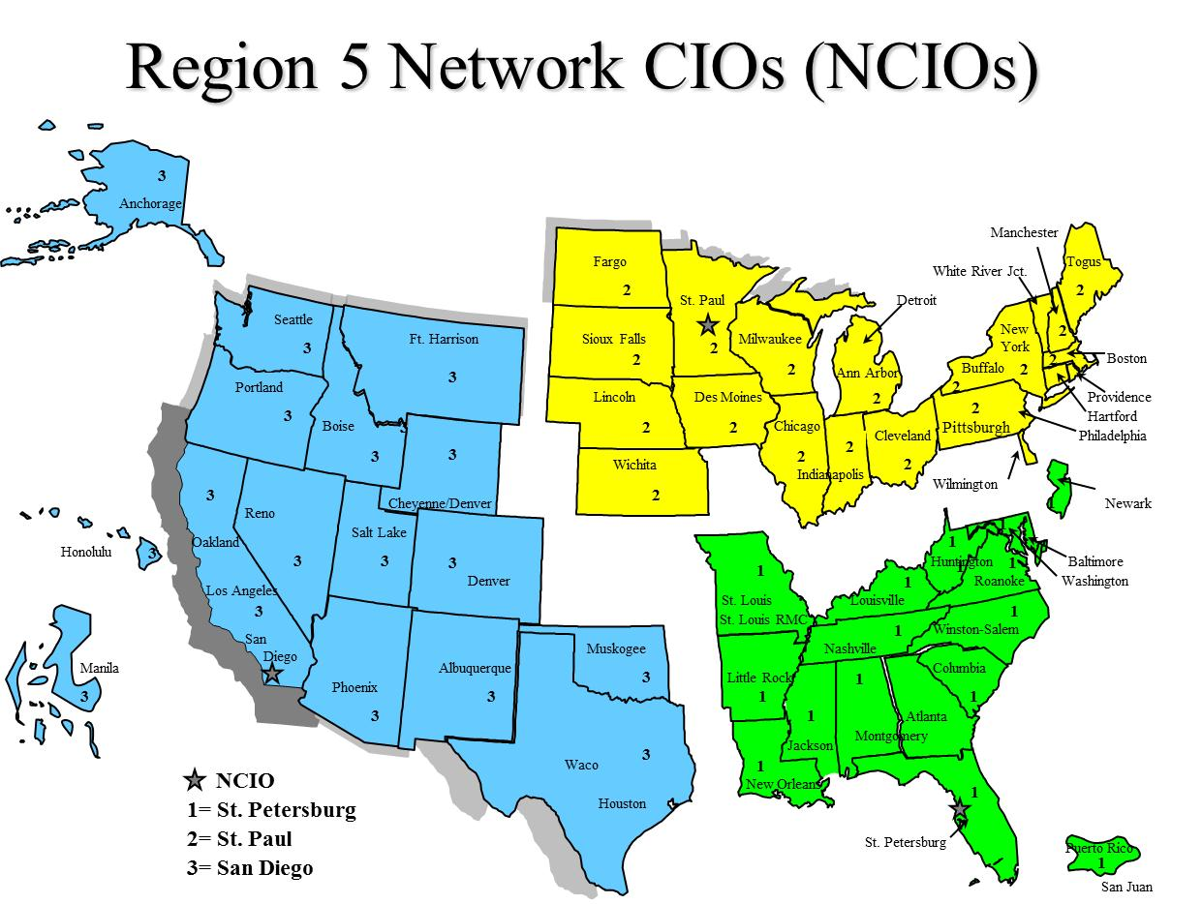

Veteran Service Organization (VSO)
All VSO offices are co-located with VBA regional offices as shown in the table of the previous Section 2.2.2. The VSO has authorized CAPRI read-only permissions for specific claimant’s EHR. This access allows the VSO to help a veteran who is preparing a VA benefit claim.
CAPRI offers VSO users:
- A national user account option with a single access/verify code, from which authorized users can view a Veteran’s entire VA health record from any site where the Veteran has been seen
- Customizable reports and health summaries
- C&P exam requests and results
- A search feature that enables users to search progress notes and discharge summaries for text
- Access to current and past AMIE C&P claims activity
- Federal Health Information Exchange (FHIE)/ DoD health data
- Access to VistAWeb for quickly viewing data at remote locations
VistAWeb is an intranet, browser-based application that provides a read-only view into EHR data. It allows the user to view data that is accessible on the reports tab of CPRS. It retrieves data for patients from all sites where the patient has visited if authorized for special user access and mirrors the behavior of the CPRS and Remote Data View (RDV), however imaging is not currently available.

National Cemetery Administration
The National Cemetery Administration does not directly use the CAPRI application, but receives its verified veteran information through VBA. VBA uses CAPRI to acquire this veteran information.

VA Office of Inspector General
The VA Office of Inspector General performs audits and conducts research for reports when directed using CAPRI accessed data.

Systems Relationship

System Architecture Diagram
The diagram associated with the following link is a high-level association of CAPRI and the systems it interfaces to. This diagram, “CAPRI Data Flow Diagram_Updated09May2012” is available at the following URL: http://vaww.oed.portal.va.gov/development/legacy_product_enhancements/healthcare_management_products/CAPRI/CAPRI%20Reference%20Documents/Forms/AllItems.aspx
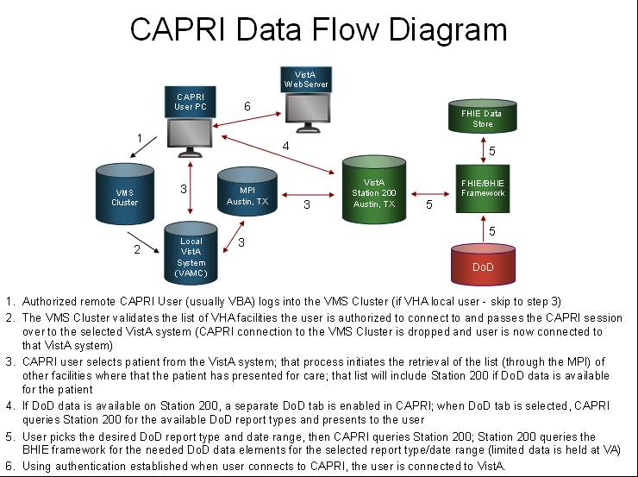

Database Integration Agreements (DBIAs)
There is a large amount of data as well as continual changes within the DBIAs. Therefore, it is recommended to follow these steps to obtain the most current and valid DBIAs for the CAPRI/AMIE package.

Custodial Agreements
A list of CAPRI/AMIE current custodial Integration Agreements (IAs) can be created by FORUM users with DBA Menu access by following these steps:
1. Log on to FORUM
2. DBA Menu
3. Integration Control Registrations Menu
4. Custodial Package Menu
5. Active ICRs by Custodial Package Option
6. Select Package Name: AMIE

Subscriber Agreements
A list of CAPRI/AMIE current subscriber IAs can be created by FORUM users with DBA Menu access by following these steps:
1. Log on to FORUM
2. DBA Menu
3. Integration Control Registrations Menu
4. Subscriber Package Menu
5. Print Active by Subscriber Package Option
6. Start with subscribing package: AUTOMATED MED INFO A
7. Go to subscribing package: AUTOMATED MED INFO Z

Account Management

Establishing CAPRI Account
CAPRI access for local VHA medical center users is managed by the local IRM/ISO staff at the medical center, just like any other application (i.e. roll-and-scroll VistA, CPRS, BCMA, etc). HIA only manages CAPRI users that authenticate/authorize through the CLAIMS system. To contact the HIA team send email to: hia.vso@va.gov
Once you obtain access and depending on your role you will be able to create additional accounts using CAPRI tools. Refer to the latest version of the CAPRI GUI User Manual in the VA (Software) Document Library (VDL), see section “Edit Remote User Site Access” at the following URL: http://www/va/gov/vdl/application.asp?appid=133

Installing CAPRI
Note: It is important that all users at your site remain on the same version.
The AMIE package must be installed and maintained at VistA sites with patient data that will be accessed through the CAPRI GUI application. Installation and configuration of the AMIE package is described in the AMIE Installation Guide, Technical Manual, and Release Notes found at: http://www.va.gov/vdl/application.asp?appid=31
The AMIE package is maintained through patches in the Department of Veterans Benefits Administration (DVBA) namespace, issued through the VistA National Patch Module (NPM).
For the VBA, the new version runs when the user starts the application from Start/Vbapps/CAPRI/CAPRI. The user can make new Windows desktop shortcuts (see Section 7.1) after starting the new version.
For the VHA, the IRM department will install the CAPRI desktop icon. Please check with them on the specifics of starting CAPRI. Normally, the user should find the CAPRI shortcut in the same place the user would find the Computerized Patient Record System (CPRS).
Local VistA Connection: The CAPRI shortcut can be set to connect to a specific VistA system. CAPRI will accept the command line parameters s=servername and p=portname, just like CPRS.
CAPRI REMOTE: CAPRI Remote users access CAPRI through the Claims system, which runs on the VHA Forum hardware. The server for those users should be set to claims.forum.va.gov, port 9400. For more details reference the latest version of the CAPRI GUI User Manual, see section “CAPRI Remote Functionality” at the following URL: http://www.va.gov/vdl/application.asp?appid=133
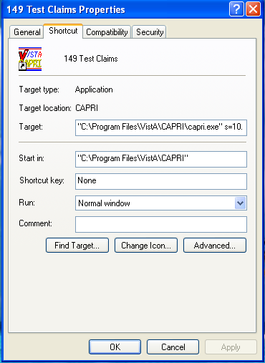

CAPRI Distribution Files

CAPRI GUI Client Software
The CAPRI GUI client software is distributed as a zipped file from which the executable CAPRI.exe is extracted. Information on downloading the installation files for the CAPRI GUI software is included in the FORUM patch announcing a new version of CAPRI. The following is a sample of a FORUM patch section describing the availability of the installation files and other documents pertaining to the GUI distribution.
Release notes are normally provided with each release to provide a list of the updates included in the patch, because not all users have access to the patch description. The user manual is included if it is updated. The distribution of these documents is at the discretion of each installing facility. The updated documents are placed on the VDL site following patch release.
The CAPRI GUI client software and documentation are available using FTP. The preferred method is to FTP the files from:
download.vista.med.va.gov (Files will be in an anonymous.software directory)
This transmits the files from the first available FTP server. Sites may also elect to retrieve software directly from a specific server as follows:
OI&T FIELD OFFICE FTP ADDRESS DIRECTORY
----------------- ----------- ---------
Albany ftp.fo-albany.med.va.gov [anonymous.software]
Hines ftp.fo-hines.med.va.gov [anonymous.software]
Salt Lake City ftp.fo-slc.med.va.gov [anonymous.software]
The following files will be available:
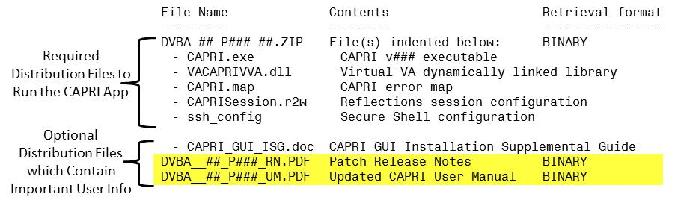
Note: The VDL web site is usually updated within 1-3 days of the release date and will contain the “Release Notes” and if updated the “CAPRI GUI User Manual” as shown in the highlighted text above. The VDL’s URL is: http://www.va.gov/vdl/applicaiton.asp?appid=133

Logging onto CAPRI
The information is this section is a combination from several different sources but most of the information can be found in the latest version of the CAPRI GUI User Manual, see section “Logging On” at the following URL: http://www.va.gov/vdl/application.asp?appid=133
Please check this main source, the latest version of the CAPRI GUI User Manual, for any updated information that may not be found here.

Desktop Icon Shortcuts Setup
Note: It is important that all users at your site remain on the same version. Additionally, there is no required fixed location for the CAPRI executable. The location is at the discretion of each installing facility. CAPRI is routinely installed in the Program Files/VistA/CAPRI directory of a user’s WinXP workstation. Many sites install the GUI on a network share drive and place a shortcut on the user’s workstations. Other sites install the GUI on a Citrix server for remote access.
For the VBA, the new version runs when the user starts the application from Start/Vbapps/CAPRI/CAPRI. The user can make new Windows desktop shortcuts after starting the new version.
For the VHA, the IRM department will install the CAPRI desktop icon. Please check with them on the specifics of starting CAPRI. Normally, the user should find the CAPRI shortcut in the same place the user would find the CPRS.
Local Vista Connection: The CAPRI shortcut can be set to connect to a specific VistA system. CAPRI will accept the command line parameters s=servername and p=portname, just like CPRS. See the “Additional Information” section; subsection “Installation”, in the latest version of the CAPRI GUI User Manual, at the following URL: http://www.va.gov/vdl/application.asp?appid=133

Non-CAPRI Remote Users
Step 1 – The user starts by double-clicking the CAPRI icon.
Step 2 – OPTIONAL – If the workstation has been configured with serverlist.exe by IRM, and if there is no server and port information in the CAPRI shortcut, a window will appear asking the user to select an initial server and port (see following screenshot). Selecting the down arrow in the upper right corner displays all the VHA sites the user can access. A scroll bar appears if the list is too long to be displayed. If the user has access to only one VHA facility, then the VistA sign on screen in Step 5 is displayed immediately.
Step 3 – OPTIONAL – The user scrolls to the name of the desired VHA facility, if it is not already visible, and clicks it to select it.
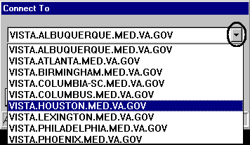
Step 4 – OPTIONAL – The user clicks OK
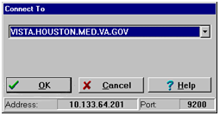
Step 5 – The user enters a VistA Access Code, presses the Tab key, and then enters the Verify Code. The user then presses Enter or clicks OK. This takes the user to the Patient Selector Screen.
Note: New users without access codes should contact local IRM staff to get one.
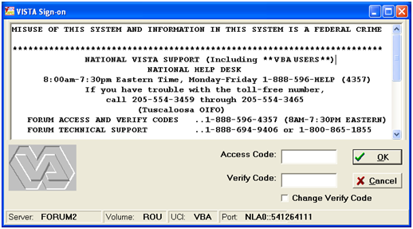

Regional Office CAPRI Remote Users
Most VBA users are CAPRI Remote users. Each CAPRI Remote user needs only one Access Code and one Verify Code to connect to authorized VA Medical Center (VAMC) sites.
Step 1 – From the Start/VBAPPS/CAPRI Remote/CAPRI Remote menu, the user clicks the CAPRI icon.
Step 2 –After entering the VistA Access Code, the user presses the Tab key to go to the next field and enters the Verify Code. Then the user presses Enter or clicks OK
Note: New users without access codes should contact local IRM staff to get one. The first time the user logs into a VistA application, only the Access Code should be entered. CAPRI will then prompt the user to create a Verify Code. Most users should have a valid Access and Verify Code combination by the time they use CAPRI.
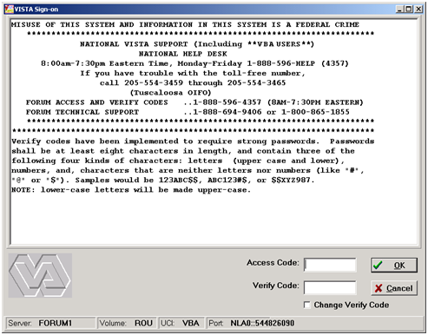
OPTIONAL – To change the Verify Code, the user selects the Change Verify Code checkbox on the sign-on dialog before clicking OK. The user will then be prompted to create a new Verify Code as shown in the steps in the following screenshot.
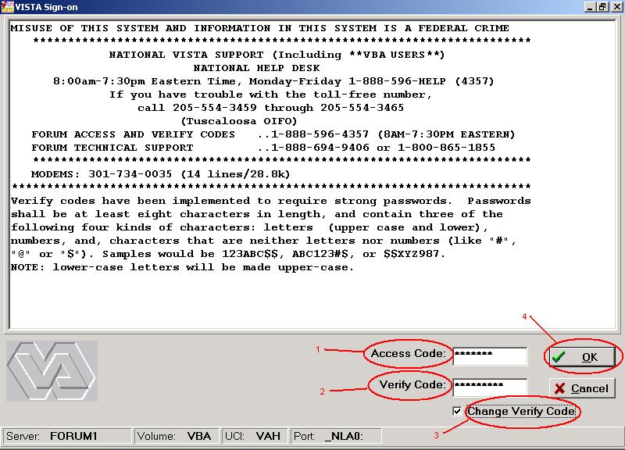
After selecting OK, the user is prompted to enter and confirm a New Verify Code
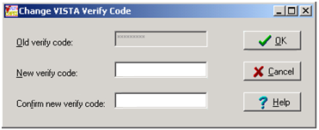
Step 3 – The CAPRI Remote site selection screen displays the user’s authorized VHA facilities. (These accesses are established when an account is initially created and/or the user request specific facilities along with the proper approvals after the account creation. This facility information is located in the CAPRI file 396.96.) When the user selects a CAPRI Remote site executable it provides the authorized remote sites. If shown, the vertical scrollbar is used to scroll through all authorized sites. The user selects a site and then either double-clicks the site’s name or clicks OK to access that site. CAPRI has been modified to include the city and state where each facility is located. In addition, the list may now be sorted by State. The following screenshot shows DEV/FEX Test System in Troy, New York as the selected VHA facility.
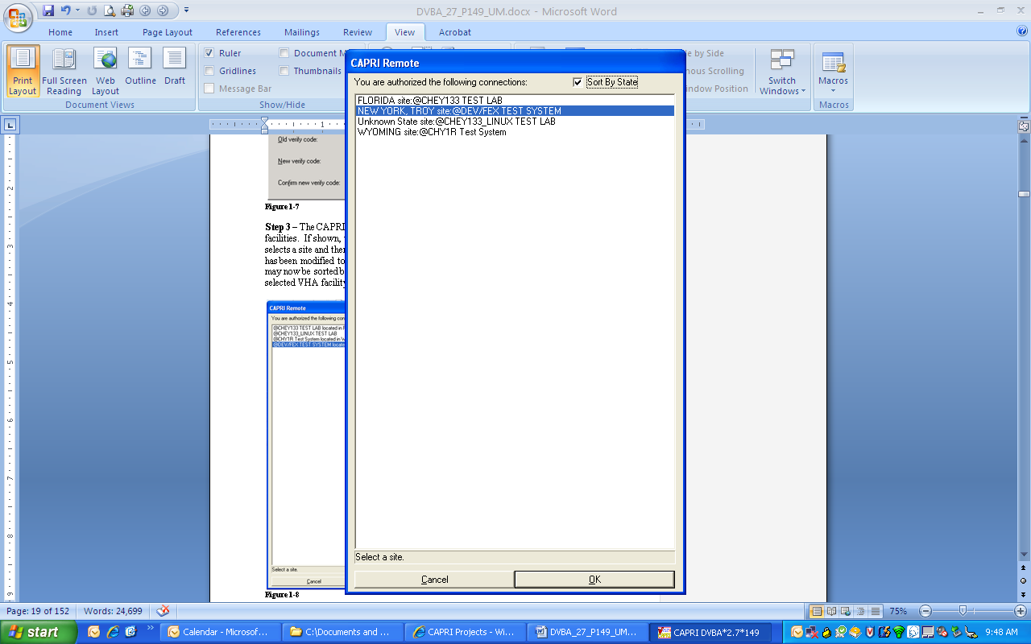
After CAPRI loads the VHA facility, the user is prompted with the Patient Selector screen. Instructions for use of the Patient Selector screen are found in section “CAPRI – Using the Software” of the latest version of the CAPRI GUI User Manual at the following URL: http://www.va.gov/vdl/application.asp?appid=133
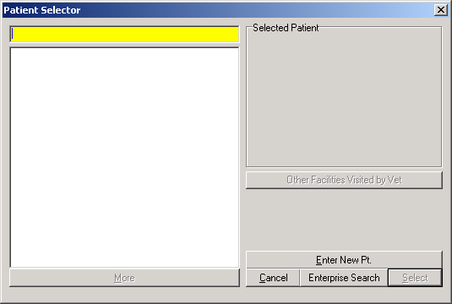

CAPRI Remote Users
CAPRI Remote users access CAPRI through the Claims system, which runs on the VHA Forum hardware. The server for those users should be set to claims.forum.va.gov, port 9400 (see screenshot below).
CAPRI Remote users outside of VBA will normally obtain an access code from the Office of Information (OI) support staff, not from the local field site. Most VBA users are CAPRI Remote users. Most VHA users are local site users. If a user starts CAPRI and does not successfully connect to a VistA system within 90 seconds, CAPRI automatically shuts down.
When users log into CAPRI remotely, CAPRI alerts users when no email account is set up.
For additional information see the CAPRI Remote Functionality section in the CAPRI GUI User Manual at the following URL: http://www.va.gov/vdl/application.asp?appid=133

VistA Terminal
The “Attachmate Reflections Secure Shell” application replaces the telnet window. CAPRI Remote users can launch a VistA Terminal session by selecting the VistA button to log into the local VistA system site they are assigned to. A dialog box is displayed when the VistA button is clicked that provides the user the ability to choose between connecting using the secure shell application or telnet. The default is set to secure shell application.
Note: Local CAPRI users will not have access to the VistA Terminal from CAPRI and the VistA button will not be available.

Terminal Server Users
Step 1 – From the Hines terminal server application, the user double-clicks the CAPRI icon.
Step 2 – Follow the instructions in the previous Section 4.3.2, Regional Office CAPRI Remote Users, Steps 2 and 3.

CAPRI News
Before logging on to CAPRI, News alerts are displayed if new items exist. The user can select the News item to view the contents.
The user can select Clear All to remove all News items.
The user can select Close to continue working with CAPRI.
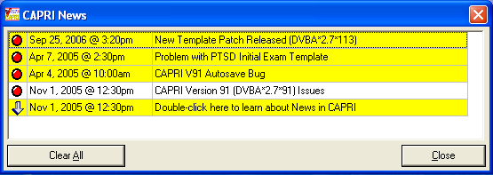

CAPRI Alerts
When users of the CAPRI C&P Template functionality log into CAPRI, any existing CAPRI Template Alerts are displayed.
CAPRI automatically checks pending Compensation and Pension Worksheet Module (CPWM) Template statuses. Pending templates in the user’s queue are displayed on the alert screen. The C&P Alert screen displays alerts according to template status. Alerts for template statuses are: draft, awaiting signature, sent back from reviewer, requiring review, CPRS documents to cosign, and cosigned documents ready to transfer to AMIE
The user clicks the Resolve This Alert button to be taken to the section of CAPRI where the alert can be resolved. For example, if the user has unsigned templates, then he or she is taken to the Unsigned Templates window.
The user may select Continue to bypass the alerts and go to the Patient Selector screen.
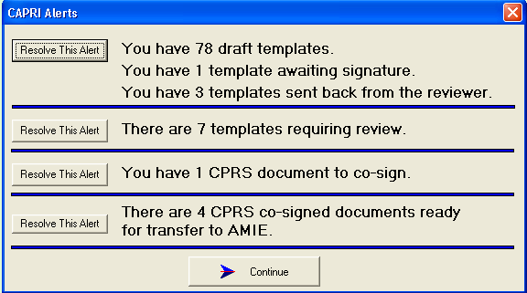

Audit Kept
The following instructions are to view your audit log. This is an example only, use your correct information to locate your log.
Example: The log file is named - DVBA_2.7_BuildVersion_dd_mm_yy.TXT
Go to: C:\Documents and Settings\YourVAUserName\Local Settings\Temp\DVBA_2.7_ BuildVersion_dd_mm_yy.txt

CAPRI Application Maintenance

CAPRI Application Software Maintenance
The National Patch Module currently resides on the FORUM server and is used to release VistA patches nationally.
Updates to the CAPRI application are distributed through the VA FORUM National Patch Module (NPM) under the DVBA namespace. The DVBA namespace is shared with the Automated Medical Information Exchange (AMIE) package. Patch names follow the format “DVBA*Version*PatchNumber”.
The patch consists of the patch description and the routines and VistA FileMan components in PackMan format for installation on the VistA server. The patch description consists of an overview description of the patch, a functional overview, a list of the components released by the patch, retrieval instructions for the software and documentation, and installation instructions for the VistA server portion of the patch.
CAPRI executable and documentation associated with the patch are retrieved from an FTP server designated by the VA for software downloads. The software retrieval instructions are always added by the developer in the SOFTWARE AND DOCUMENTATION RETRIEVAL section of the patch description. A separate installation guide is provided with each CAPRI patch that provides instructions for installing the CAPRI GUI. New versions of the CAPRI GUI do not require installation of previous versions.
The Associated Patches section of the Patch Description lists any previous patches that must be installed prior to the new patch. The Functional Overview section of the patch describes the functional and technical changes included in the patch. The Installation Requirements section provides detailed instructions on the installation of all patch components.
When a CAPRI patch includes new GUI, the Software and Documentation Retrieval section indicates the name of the GUI distribution (zip) file, the installed executable version, and the file size. This section also provides primary and alternative FTP download locations of the installation file, any Release Notes, and other updated documentation files. Updated patch documentation is uploaded to the VDL within three days of the patch release at the following URL:
http://www.va.gov/vdl/application.asp?appid=133
When a CAPRI patch contains a new GUI version, users should be aware of any notes regarding the timing of installation of the M components and providing the new GUI to users.
VA staff with access to FORUM can subscribe to receive notification of newly released CAPRI patches by selecting the FORUM “Patch User Menu” option, “Select Packages for Notification” sub-option, then selecting the AMIE package.

C&P Worksheet Template Maintenance
CAPRI template files are in an ever evolving environment. To obtain the latest information available information it is best to retrieve a list each time.
CAPRI examination templates are stored in the CAPRI TEMPLATE DEFINITION file. This file maintains a list of definitions used to generate examination templates in the CAPRI Graphical User Interface (GUI). Entries in the CAPRI TEMPLATE DEFINITION file are used by the CAPRI application to create the examination templates in the CAPRI GUI. Retired template definitions are retained in the file for historical purposes. This file should remain standardized between all sites. No additions, modifications, or editions should be made to this file except through the remote PUSH utility.
Entries in the CAPRI TEMPLATE DEFINITION file are maintained remotely. The Business Engineering Services Team (BEST) team manages the CAPRI TEMPLATE DEFINITION file using the CAPRI Template PUSH utility. Organizationally, the (BEST) falls under Systems Management within the VHA Chief Business Office (CBO). Insight into this utility can be gained from the CAPRI PUSH DBQ Utility User Manual document at the following URL:
http://www.va.gov.vdl/application.asp?appid-133
This utility is used only by BEST staff. PUSH utility users log onto the CLAIMS Server for authentication and verification. The user performing a PUSH operation must be assigned the option DVBA MANAGE CAPRI TMPLTES GUI option. This option exists only on the CLAIMS and TEST CLAIMS systems, since this is where the operator is authenticated and where the initial context is created. The option DVBA CAPRI GUI is used to create the context for connection to sites where the template definitions are actually updated. Questions about and issues with the PUSH utility should be addressed to: VHA CBO BEST Staff.

Applications Development Tools and Usage

Delphi 2006 Development Software
This section includes the Delphi 2006 installation procedure, installation of third-party components, and their purpose and usage. This documentation is currently available in draft format in SharePoint at: http://vaww.oed.portal.va.gov/development/legacy_product_enhancements/healthcare_management_products/CAPRI/CAPRI%20Reference%20Documents/Forms/AllItems.aspx
Upon final approval this document will be posted in the VDL at: http://www.va.gov/vdl/application.asp?appid=133

Code Repository Tool (Version Control)
The Delphi application utilizes the Rational ClearCase tool for version control. Its VA approval documentation is located at URL: http://www.va.gov/TRM/ToolPage.asp?tid=39
Per this VA URL, it is recommended to go directly to IBM’s Rational ClearCase website at URL: http://www-01.ibm.com/software/awdtools/clearcase/
for any additional current application information.

CAPRI Source Files for Delphi 2006
The CAPRI application is developed in Delphi 2006. Standard source file name extensions are preserved as required by the development tool. These file name extensions are .dfm, .pas, .res, and .drc
The CAPRI source files are stored on a Rational ClearQuest Server. Your code must be checked into ClearQuest once modifications have passed testing by the developer.
Due to the longevity of the CAPRI project only limited unit description and usage is available. The developer will need to reference the CAPRI GUI User Manual to obtain and understand what logic occurs when executing the application. By using the CAPRI GUI User Manual, adding break points in the Delphi 2006 IDE, the developer will obtain an understanding of the Functions, Procedures, RPCs, input and output file, and parameter list and usage.
Select the latest version of the CAPRI GUI User Manual at the following URL: http://www.va.gov/vdl/application.asp?appid=133
For any additional assistance refer to Section 1.4, CAPRI Technical Support, for contact information.

CAPRI Remote Procedure Calls (RPCs) for MUMPS
See Appendix A for a list of detailed RPCs used by the CAPRI Graphical User Interface (GUI) software.
To duplicate the list of RPCs in Appendix <>, do the following:
1. Type "D P^DI" to start Fileman.
2. At "Select OPTION:", select option 2, "PRINT FILE ENTRIES".
3. At "OUTPUT FROM WHAT FILE:", enter "REMOTE PROCEDURE".
4. Accept the default for "SORT BY: NAME//" by hitting RETURN.
5. At "START WITH NAME: FIRST//", enter "DVBA" to start with the first CAPRI RPC name.
6. At "GO TO NAME: LAST//", enter "DVBC" to list all of the CAPRI namespace RPCs.
7. Accept the default for "WITHIN NAME, SORT BY:"
8. At "FIRST PRINT FIELD:", Enter a "?" and then "Y" for "Do you want the entire nn-Entry FIELD list?". The list will be displayed for you to choose from.
9. At "FIRST PRINT FIELD:" prompt, enter ".01" for NAME. At each successive "THEN PRINT FIELD:" prompt, enter the field numbers listed here:
.02 TAG
.03 ROUTINE
.04 RETURN VALUE TYPE
.06 INACTIVE
1 DESCRIPTION (word-processing)
2 INPUT PARAMETER
At "THEN PRINT INPUT PARAMETER SUB-FIELD:" after entering "2", click RETURN to bypass sub-fields.
3 RETURN PARAMETER DESCRIPTION
10. At the next "THEN PRINT FIELD:", press RETURN to complete the list of desired fields.
11. For the heading, answer "Replace" with "REM...", then answer "With" with RETURN to remove a heading, or enter a heading.
12. At the "STORE PRINT LOGIC IN TEMPLATE:" select or create a Print Template, or take the default to bypass creating a print template.
13. At "DEVICE:", answer "0;80;99999" to display the RPC listing to your screen.
Copy and paste the results into a word processing application for possible cleanup.
This is an example of the dialog:
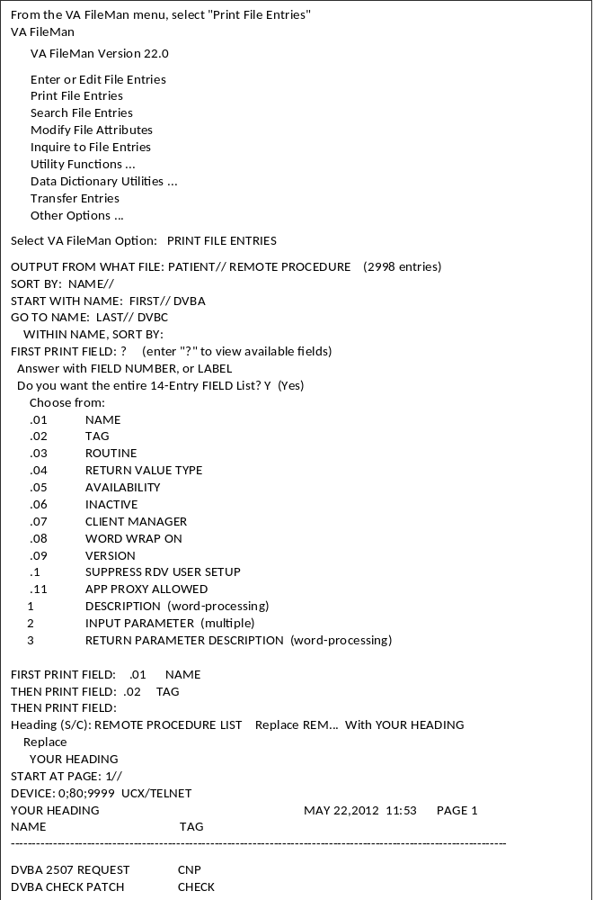

Fileman

Installation Procedures and Usage
All VA FileMan documentation is available on the VDL, accessible at the following URL: http://www.va.gov/vdl/application.asp?appid=5
There is also additional documentation regarding other FileMan information i.e. FileMan Tips, etc… is accessible at: http://www.hardhats.org/index.html
Note: Using the Freedom of Information Act this website obtained documentation from the VA for VISTA. In general this site gathers information from multiple sources including the VA website.

Environmental Setup
The VA FileMan V.22 Key and Index Tutorial document contains the environmental setup information at the following URL: http://www.va.gov/vdl/documents/Infrastructure/Fileman/fm22_tutorial.pdf

Installation Guide
Access the VA FileMan Installation Guide at: http://www.va.gov/vdl/documents/Infrastructure/Fileman/fm22_0ig.pdf

Getting Started
Access the VA FileMan Getting Started User Manual at: http://www.va.gov/vdl/documents/Infrastructure/Fileman/fm22_0gs.pdf

FileMan Access Codes
The following table is a list of recommended VA FileMan access codes associated with each file contained in the AMIE software.
FILE NUMBER | FILE NAME | DD ACCESS | RD ACCESS | WR ACCESS | DEL ACCESS | LAYGO ACCESS
31 | Disability Condition | @ | D | @ | @ | @
396 | Form 7131 | @ | # | # | # | #
396.1 | AMIE Site Parameter | @ | # | # | @ | @
396.2 | AMIE Report | @ | # | # | # | #
396.3 | 2507 Request | @ | # | # | # | #
396.4 | 2507 Exam | @ | # | # | # | #
396.5 | 2507 Cancellation Reason | @ | # | @ | @ | @
396.6 | AMIE Exam | @ | # | @ | @ | @
396.7 | 2507 Body System | @ | # | @ | @ | @
396.94 | 2507 Insufficient Reasons | @ | # | @ | @ | @
396.95 | AMIE C&P Exam Tracking | @ | # | # | # | #
Note: The code (symbol) “@” in this table is the programmer’s access. The other codes are arbitrary, and are determined by the developers during the design phase and assigned as needed to users by the Information Systems (IS) staff in the File Manager Access Code field of the New Person (#200) file.

Advanced User
Access the VA FileMan Advanced User Manual at: http://www.va.gov/vdl/documents/Infrastructure/Fileman/fm22_0um.pdf

Programmer Manual
Access the VA FileMan Programmer Manual at: http://www.va.gov/vdl/documents/Infrastructure/Fileman/fm22_0pm.pdf

Technical Manual
Access the VA FileMan Technical Manual at: http://www.va.gov/vdl/documents/Infrastructure/Fileman/fm22_0tm.pdf

Package-wide Variables
There are no package-wide or special variables in the AMIE software.

Key Variables
- PNAM = Patient name
- DFN = Internal ^DPT number
- SSN = Social security number
- CFLOC = Claim folder location
- DCHGDT = Discharge date
- ADMDT = Admission date

How to Generate Online Documentation
This section describes some of the various methods by which users may secure AMIE technical documentation. Online technical documentation pertaining to the AMIE software, in addition to that which is located in the help prompts may be generated through utilization of several Kernel options. These include XINDEX and VA FileMan List File Attributes. Further information about other utilities which supply online technical documentation may be found in the Kernel Reference Manual.

XIndex
This option analyzes the structure of a routine(s) to determine in part if the routine(s) adheres to VistA Programming Standards. The XINDEX output may include the following components: compiles list of errors and warnings, routine listing, local variables, global variables, naked globals, label references, and external references. By running XINDEX for a specified set of routines, the user is afforded the opportunity to discover any deviations from VistA Programming Standards which exist in the selected routine(s) and to see how routines interact with one another, that is, which routines call or are called by other routines.
To run XINDEX for the AMIE software, specify the following namespace at the "routine(s) ?>" prompt: DVBA* and DVBC*. AMIE initialization routines which reside in the UCI in which XINDEX is being run, as well as compiled template routines found within the AMIE namespace, should be omitted at the "routine(s)?>" prompt. To omit routines from selection, preface the namespace with a minus sign (-).

Data Dictionary List File Attributes
This VA FileMan option allows the user to generate documentation pertaining to files and file structure. Utilization of this option via the "Standard" format will yield the following data dictionary information for a specified file(s): file name and description, identifiers, cross-references, files pointed to by the file specified, files which point to the file specified, input templates, print templates, and sort templates. In addition, the following applicable data is supplied for each field in the file: field name, number, title, global location, description, help prompt, cross-reference(s), input transform, date last edited, and notes.
Using the "Global Map" format of this option generates an output which lists all cross-references for the file selected, global location of each field in the file, input templates, print templates, and sort templates.
For a comprehensive listing of AMIE files used by CAPRI, please use the following link (URL) to locate the “Files” section of the AMIE Technical Manual: http://www.va.gov/vdl/application.asp?appid=31

Archiving, Purging, and Frequency
CAPRI relies on the AMIE application for any archiving and purging functionality.
Although the AMIE software has no archiving capabilities AMIE’s purging capabilities are handled by the DVBA REGIONAL PURGING PROGRAM option deletes all FINALIZED requests which are older than the date set in the AMIE SITE PARAMETER file (#396.1). It should normally be set to run daily on TaskMan, as it takes several minutes to run in programmer mode. In addition to purging the FORM 7131 file (#396), it also purges the AMIE REPORT file (#396.2).
The frequency is based on the amount of 7131 information purged by this program. It is determined by the NUMBER OF DAYS TO KEEP HISTORY parameter set through the Regional File Site Parameter Setup option. It is suggested to keep at least 30 days on file at all times, but no more than 120 days. The NUMBER OF DAYS TO KEEP HISTORY field (#9) of the AMIE SITE PARAMETER file (#396.1) will automatically keep 30 days of report data if no value is in that field.
While the AMIE software uses a very small amount of disk space, it is wise not to let the data accumulate if it is not needed by the hospital.
The DVBA C Purge 2507 option deletes all 2507 requests with the following statuses and that are older than the number of days in the DAYS TO KEEP 2507 HISTORY parameter: Completed, Printed by RO; Completed, Transferred Out; Cancelled by Medical MAS; Cancelled by RO. This option should be scheduled through TaskMan to run nightly. It may be run in programmer mode but will take several minutes. The 2507 EXAM (#396.4) file will be purged in conjunction with the 2507 REQUEST file (#396.3).

Security

Security Management
VA Directive 10-93-142 prohibits local modifications to VistA software.

General Security
For CAPRI GUI security refer to the following document: http://www.va.gov/vdl/documents/Financial_Admin/CAPRI/dvba_27_p000_um.pdf
This manual includes instructions for setting up CAPRI users, as well as descriptions of all Security Keys used by the CAPRI GUI application.
For AMIE file and VistA-specific security see the CAPRI GUI User Manual at: http://www.va.gov/vdl/application.asp?appid=133

Remote Systems
The AMIE software does not transmit data to any remote systems. For CAPRI interactions with remote systems, refer to the Systems Architecture diagram in Section 3.1.1.

Contingency Planning
Your facility should have a local contingency plan in the event of application problems in a live environment. It should identify the procedure for maintaining functionality provided by the AMIE software as well as the CAPRI GUI application, in the event of system outage.

Interfacing
There are no special interfacing requirements for the AMIE or the CAPRI software.

Electronic Signatures
The CAPRI GUI application uses electronic signatures. Use the following link to locate the CAPRI GUI User Manual: http://www.va.gov/vdl/application.asp?appid=133

Security Keys
Take the following steps to get information about the security keys used with the AMIE software.
1. VA FileMan Menu
2. Print File Entries Option
3. Output from what File: SECURITY KEY
4. Sort by: Name
5. Start with name: DVBA to DVBC
6. Within name, sort by: <RET>
7. First print field: Name
8. Then print field: Description
Note: Some keys do not affect the menu operation. This is due to some options having several different functions which are limited in scope by the key. This limitation is done internally by the program being used.

CAPRI Troubleshooting and Error Information
Note: In all cases, please print the error message for your local IRM staff.
A majority of CAPRI issues that are initially called into the Service Desk or are created into Remedy tickets are not often CAPRI related issues, but are due to other issues regarding networks and users accesses/permissions, etc... Those few CAPRI issues that are identified as a CAPRI issue are forwarded onto the CAPRI Team. The team works to replicate and identify the issue, then to develop solutions or workarounds to correct or eliminate the issue. Some of these issues result in identification of a CAPRI defect or an issue that may become a future CAPRI enhancement. These issues are often unique and not reported in any significant numbers. The CAPRI Team forwards these specific issues onto the VA who will determine if the issue(s) is something that should be recognized as a defect or a possible CAPRI enhancement scheduled for one of the next CAPRI patch installation deployment.
The remainder of this section includes general CAPRI troubleshooting and error information that is located in the CAPRI GUI User Manual at the following URL: http://www.va.gov/vdl/application.asp?appid=133
Select the latest version of the document; refer to the section “Troubleshooting and Error Messages”.

CAPRI Not Installed in VistA
The user receives the message in the following screenshot if the VHA Medical Center has not loaded the VHA half of the CAPRI software. The user should contact local IRM staff after receiving this message.
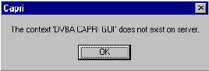

CAPRI GUI Option Not Assigned to User in VistA
The user receives the message in the following screenshot if the VHA medical center has not assigned the CAPRI option to RO users. The user must contact local IRM staff upon receiving this message.
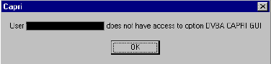

VistA Server Down
The user receives the message in the following screenshot, or a similar one such as WSAETIMEDOUT, when there are performance issues in the VA Wide Area Network (WAN), if a server is down, or if a server was not restarted after being down. When this happens, AMIE II may or may not connect, depending on the exact problem. The user should test the AMIE II connection.
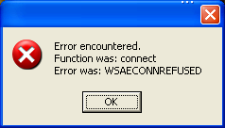

VistA Limits Ability to See Patient Records
The user receives the message in the following screenshot if the medical facility made local permission modifications in VistA that prohibit users from seeing the contents of patient records.
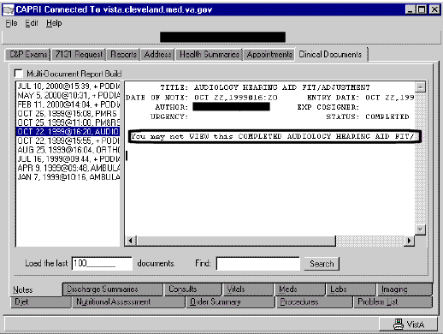

Network Problems
The user receives the message in the following screenshot if the connection to the medical facility is lost unexpectedly. The user should try to connect to the medical facility again.
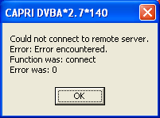

Institution File in VistA has Been Locally Modified
The user may receive the message in the following screenshot when requesting exams, requesting 7131s, or entering new patients if the VHA medical facility has an incomplete or incorrect Regional Office list in their system.
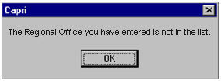

Too Many Invalid Attempts at Access Code / Verify Code
The user receives the message in the following screenshot if the user attempted to log on and entered the wrong Access Code / Verify Code combination three or more times.
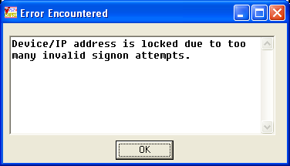

Multiple Sign-Ons
The user may receive the message in the following screenshot if the user did not log out of CAPRI correctly or if the session was unexpectedly disconnected.
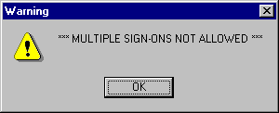

General Error Message
The user may receive the message in the following screenshot for a number of reasons. Upon receiving this message, the user should cancel the current task, close CAPRI, and sign on again. If the user receives this error message again, local IRM staff should be contacted for assistance.
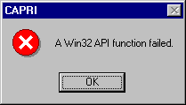

Appendix A - CAPRI Remote Procedure Calls for MUMPS
The DVBA CAPRI GUI menu option contains all the CAPRI RPCs.

Name: DVBA CAPRI GUI
Menu Text: Capri GUI (Broker)
Type: Broker (Client/Server)
Package: AUTOMATED MED INFO EXCHANGE
Description: This is the “B” type option used by CAPRI GUI client application. It contains all the RPCs used by the CAPRI GUI application.
The table that starts on the next page shows a correlation between the CAPRI’s MUMPS RPCs and DELPI’s RPCs associated within supporting the CAPRI application.

MUMPS |  |  |  |  |  |  | DELPHI
NAME | TAG | ROUTINE | RETURN VALUE TYPE | DESCRIPTION | INPUT PARAMETER (Multiple) | RETURN PARAMETER DESCRIPTION | Procedure Name | Locations | Broker Name | Parameter
DG SENSITIVE RECORD ACCESS | PTSEC | DGSEC4 | ARRAY | This Remote Procedure Call (RPC) will:  - Verify user is not accessing his/her own Patient file record if the Restrict Patient Record Access (#1201) field in the MAS parameters (#43) file is set to yes and the user does not hold the DG RECORD ACCESS security key. If parameter set to yes and user is not a key holder , a social security number must be defined in the New Person file for the user to access any Patient file |  | RESULT(1) =  -1-RPC/API failed Required variable not defined  0-No display/action required Not an employee, not sensitive or not accessing own Patient record  1-Display warning message Sensitive - inpatient or a DG SENSITIVITY key holder or Employee and DG SECURITY OFFICER key holder  2-Display warning message, require OK to continue and call DG SENSITIVE RECORD BULLETIN RPC to update DG Security Log file and generate Sensitive Record Access mail message. Sensitive - not an inpatient and not a key holder or Employee/not a DG SECURITY OFFICER key holder  3-Access to record denied Accessing own Patient file record  4-Access to Patient file (#2) records denied SSN not definedRESULT(2-n) = error message or warning/Privacy | DG SENSITIVE RECORD ACCESS'  'DG SENSITIVE RECORD ACCESS' | patientlist  patientlistrestricted | RPCBroker1  RPCBroker1 | FMCvrListBox1Pt.GetselectedRecord.IEN  or  FMCvrListBox2Pt.GetselectedRecord.IEN  or  FMCvrListBox3Pt.GetselectedRecord.IEN  PType := literal; for all params  FMListBox1.GetSelectedRecord.IEN;  PType := literal;

MUMPS |  |  |  |  |  |  | DELPHI
NAME | TAG | ROUTINE | RETURN VALUE TYPE | DESCRIPTION | INPUT PARAMETER (Multiple) | RETURN PARAMETER DESCRIPTION | Procedure Name | Locations | Broker Name | Parameter
 |  |  |  | record.  - Determine if user accessing a sensitive record or an employee's record |  | Act message. Error and warning messages will begin in RESULT(2) array. The Privacy Act message is the longest message and will utilize RESULT(2)- RESULT(8).  If RESULT(1)=1, the DG Security Log file is updated.  If RESULT(1)=2, the user must acknowledge they want to access the restricted record and the application must call the DG SENSITIVE RECORD BULLETIN RPC to update the DG Security Log file and generate the Sensitive Record Access mail message.
DG SENSITIVE RECORD BULLETIN | NOTICE | DGSEC4 | SINGLE VALUE | This Remote Procedure Call (RPC) will add an entry to the DG SECURITY LOG (#38.1) file and/or generate the sensitive record access bulletin depending on the value in ACTION input parameter. If ACTION parameter not defined, defaults to update DG Security Log file and generate Sensitive Record Access mail message. |  | RESULT=  1 - successfully added entry and/or generated sensitive record access bulletin  0 - unsuccessful | DG SENSITIVE RECORD BULLETIN' | patientlistrestricted | RPCBroker1 | PatientIEN  PType := literal;  'DVBA CAPRI GUI^Capri GUI (Broker)'  PType := literal;  ' '  PType := literal;

MUMPS |  |  |  |  |  |  | DELPHI
NAME | TAG | ROUTINE | RETURN VALUE TYPE | DESCRIPTION | INPUT PARAMETER (Multiple) | RETURN PARAMETER DESCRIPTION | Procedure Name | Locations | Broker Name | Parameter
DVBA CHECK PATCH | CHEC | DVBAB1B | SINGLE VALUE | This RPC is a wrapper for the supported $$PATCH^XPDUTL API to determine whether a given patch is installed or not "1^Patch Is Installed" is returned on success; otherwise "0^Patch Is Not Installed" is returned. | DVBPATCH | Returns "1^Patch Is Installed" on success; otherwise returns "0^Patch Is Not Installed". | DVBA CHECK PATCH' | CAPRISupport | RPCBroker1 | No Params
DVBA FIX MOVED MESSAGE | SETMLMS | DVBAB1 | SINGLE VALUE | Using Delphi Fileman controls to manage mail messages does not provide adequate control over new global nodes. This routine allows a newly created message to be assigned to a specific mailbox and IEN within the mailbox instead of sequentially, which is the default behavior. Used during message termination, deletion, or moving a message to a new box. | param1  param2 |  | DVBA FIX MOVED MESSAGE' | MailMessage | RPCBroker1 | tempIEN PType:= literal; '.5'; // .5= Wastebasket PType := literal

MUMPS |  |  |  |  |  |  | DELPHI
NAME | TAG | ROUTINE | RETURN VALUE TYPE | DESCRIPTION | INPUT PARAMETER (Multiple) | RETURN PARAMETER DESCRIPTION | Procedure Name | Locations | Broker Name | Parameter
DVBAB ATE LIST | LST | DVBABAT | GLOBAL ARRAY | Return list of Audit Trail Entries in 395.98 | ZIEN  ZCNT | Y(0) is NXT^CNT; CNT=count fetched, NXT=IEN to begin NEXT fetch (0 if No More)  Y(1) thru Y(CNT) are "^" piece separated as follows:  Piece - Description  1 - USER NAME  2 - PATIENT NAME  3 - PATIENT ICN  4 - PATIENT SSN  5 - REMOTE SITE NAME  6 - DATE/TIME ACCESSED  7 - SENSITIVE RECORD?  8 - CLAIM NUMBER  9 - DIVISION TEXT | DVBAB ATE LIST' | Audit | RPCBroker1 | No Params
DVBAB ATE QUANTITY | NUM | DVBABAT | SINGLE VALUE | Get number of entries in Audit Trail. |  |  | DVBAB ATE QUANTITY' | Audit | RPCBroker1 | No Params
DVBAB CHECK CREDENTIALS | CHKCRED | DVBAB1 | SINGLE VALUE | Verifies the user has been granted access to AMIE II/CAPRI |  |  | DVBAB CHECK CREDENTIALS'  'DVBAB CHECK CREDENTIALS' | viewaddress  viewexam | RPCBroker1  RPCBroker1 | No Params  No Params
DVBAB DATETIME | DTTM | DVBAB1 | SINGLE VALUE | Returns the current date/time from VistA |  |  | DVBAB DATETIME'  'DVBAB DATETIME' | REPORTS  telnet | RPCBroker1  RPCBroker1 | No Parms  No Params

MUMPS |  |  |  |  |  |  | DELPHI
NAME | TAG | ROUTINE | RETURN VALUE TYPE | DESCRIPTION | INPUT PARAMETER (Multiple) | RETURN PARAMETER DESCRIPTION | Procedure Name | Locations | Broker Name | Parameter
DVBAB DOD INFO | INFOMSG | DVBABDOD | SINGLE VALUE | This remote procedure call returns a message to be displayed in CAPRI. The RPC is designed specifically for the FHIE VistA server not the local VAMC facilities. It is distributed nationally with the CAPRI application to keep the remote procedures and the DVBA CAPRI GUI option consistent on all systems using CAPRI. Please do not use. |  |  | DVBAB DOD INFO | Main | RPCBrokerDOD | No Params

MUMPS |  |  |  |  |  |  | DELPHI
NAME | TAG | ROUTINE | RETURN VALUE TYPE | DESCRIPTION | INPUT PARAMETER (Multiple) | RETURN PARAMETER DESCRIPTION | Procedure Name | Locations | Broker Name | Parameter
DVBAB DOD REPORT | SENDRPT | DVBABDOD | GLOBAL ARRAY | This remote procedure call returns a DOD report from the FHIE framework. The RPC is designed specifically for the FHIE VistA server not the local VAMC facilities. It is distributed nationally with the CAPRI application to keep the remote procedures and the DVBA CAPRI GUI option consistent on all systems using CAPRI. Please do not use.  Input: IEN = Patient's DFN  DATATYPE = Type of data being requested  BEGDATE = Beginning search date  ENDDATE = Ending search date  ORMAX = Max number of entries for report | IEN  DATATYPE  BEGDATE  ENDDATE  ORMAX |  | DVBAB DOD REPORT' | Main | RPCBrokerDOD | No Params

MUMPS |  |  |  |  |  |  | DELPHI
NAME | TAG | ROUTINE | RETURN VALUE TYPE | DESCRIPTION | INPUT PARAMETER (Multiple) | RETURN PARAMETER DESCRIPTION | Procedure Name | Locations | Broker Name | Parameter
DVBAB DOD REPORT TYPES | RPTTYPS | DVBABDOD | ARRAY | This remote procedure call returns a list of available report types. The RPC is designed specifically for the FHIE VistA server not the local VAMC facilities. It is distributed nationally with the CAPRI application to keep the remote procedures and the DVBA CAPRI GUI option consistent on all systems using CAPRI. Please do not use. |  |  | DVBAB DOD REPORT TYPES' | Main | RPCBrokerDOD | No Params
DVBAB EXAMS BY DATE | EXAMBYDT | DVBABEBD | GLOBAL ARRAY | Provides a report by date range of all AMIE/CAPRI exam requests. | BEGDT  ENDT |  | DVBAB EXAMS BY DATE' | REPORTS | RPCBroker1 | Value := FMToDateConvert(FormatDateTime('mm/dd/yyyy', DateTimePicker1.DateTime));  PType := literal  Value := FMToDateConvert(FormatDateTime('mm/dd/yyyy', DateTimePicker2.DateTime))  PType := literal

MUMPS |  |  |  |  |  |  | DELPHI
NAME | TAG | ROUTINE | RETURN VALUE TYPE | DESCRIPTION | INPUT PARAMETER (Multiple) | RETURN PARAMETER DESCRIPTION | Procedure Name | Locations | Broker Name | Parameter
DVBAB FETCH 1U4N | U1N4 | DVBABFRM | GLOBAL ARRAY | Retrieve the 1u4n field for the list of patient IENS provided as the only argument. Each IEN will be sent back with field .0905 appended after a caret. | ARR | List of Patient IENs in piece 1,followed by 1U4N in piece 2 | DVBAB FETCH 1U4N' | unsigned | RPCBroker1 | Mult[IntToStr(i + 1)] := FMListBoxIPR1.GetSelectedRecord.IEN;  PType := list;
DVBAB FIND DFN BY ICN | ICN | DVBABDOD | GLOBAL ARRAY | This remote procedure call returns the patient's DFN associated with the ICN passed to the RPC. The DFN is the internal entry number in the Patient (#2) file. The RPC is designed specifically for the FHIE VistA server not the local VAMC facilities. It is distributed nationally with the CAPRI application to keep the remote procedures and the DVBA CAPRI GUI option consistent on all systems using CAPRI. Please do not use. | ICN |  | DVBAB FIND DFN BY ICN' | Main | RPCBrokerDOD | No Params

MUMPS |  |  |  |  |  |  | DELPHI
NAME | TAG | ROUTINE | RETURN VALUE TYPE | DESCRIPTION | INPUT PARAMETER (Multiple) | RETURN PARAMETER DESCRIPTION | Procedure Name | Locations | Broker Name | Parameter
DVBAB FIND DUPS | DUP | DVBAB84 | GLOBAL ARRAY | Find potential duplicates within the PATIENT File (#2) At least one of NAM, DOB, or SSN must be passed Possible matches are "better" when more than one of these is passed | NAM  DOB  SSN | BYREF - Passed by reference, will contain name of a TMP Global housing the results Subscript 0: -1^ERROR_MESSAGE (in the event of an error)  OR  Subscript 0: Number of potential matches found (if no errors)  Subscript 1-K: Patient's matching ALL 3 of NAM, DOB, SSN have a weighting of 3 (see Note)  Subscript K+1-L: Patient's matching ANY 2 of NAM, DOB, SSN have a weighting of 2 (see Note)  Subscript L+1-M: Patient's matching ONLY 1 of NAM, DOB, SSN have a weighting of 1 (see Note)  ^TMP(1-M) = DFN^ZERO_NODE where DFN is the Patient IEN ZERO_NODE is the data from ^ DPT(DFN,0)  NOTE: Potential matches within a weighting (if any) will be sorted by Patient Name | DVBAB FIND DUPS'  'DVBAB FIND DUPS' | EnterPt  entersimple | RPCBroker1  RPCBroker1 | nam := LastName.text + ',' + FirstName.text;  nam := LastName.text + ',' + FirstName.text;

MUMPS |  |  |  |  |  |  | DELPHI
NAME | TAG | ROUTINE | RETURN VALUE TYPE | DESCRIPTION | INPUT PARAMETER (Multiple) | RETURN PARAMETER DESCRIPTION | Procedure Name | Locations | Broker Name | Parameter
DVBAB FIND EXAMS | FINDEXAM | DVBAB1 | ARRAY | Lists all of the patient's AMIE II C&P exam requests whether complete, new or pending. | INPUT1 |  | DVBAB FIND EXAMS'  'DVBAB FIND EXAMS'  'DVBAB FIND EXAMS'  'DVBAB FIND EXAMS'  'DVBAB FIND EXAMS'  'DVBAB FIND EXAMS' | ManageReports  loadexamcomments  newexam  tiusign  uncosignedutility  viewexam | RPCBroker1  RPCBroker1  RPCBroker1  RPCBroker1  RPCBroker1  RPCBroker1 | FMExamRequestListbox.GetSelectedRecord.IEN  PType := literal;  FMExamRequestListbox.GetSelectedRecord.IEN  PType := literal;  FMExamRequestListbox.GetSelectedRecord.IEN  PType := literal;  Value := FMExamRequestListbox.GetSelectedRecord.IEN;  PType := literal;  Value := FMExamRequestListbox.GetSelectedRecord.IEN;  PType := literal;  frmMain.FMExamRequestListbox.GetSelectedRecord.IEN;  PType := literal;  PType := literal;

MUMPS |  |  |  |  |  |  | DELPHI
NAME | TAG | ROUTINE | RETURN VALUE TYPE | DESCRIPTION | INPUT PARAMETER (Multiple) | RETURN PARAMETER DESCRIPTION | Procedure Name | Locations | Broker Name | Parameter
DVBAB FORM DATA BACKUP | BACKUP | DVBABFRM | SINGLE VALUE | Makes a backup copy of a CAPRI template in case of data loss. The backup is restored through the CAPRI GUI. | DVBIEN  LISTBOX TEXT |  | DVBAB FORM DATA BACKUP' | PNCSMain | RPCBroker1 | Piece(xFMEdit2.IENS, ',', 1);  PType := literal;  or  'MANAGE TEMPLATES restore-point'  PType := literal;  or  'Template CLOSED / ' + VersionUser;  PType := literal;  or  'TEMPLATE RESTORE restore-point ';  PType := literal;  or  SaveName + ' / ' + VersionUser;  PType := literal;  or  frmMain.RPCBroker1.Param[2].Value + ' / ' + AuthorName;
DVBAB FORM DATA BACKUP DELETE | DELETE | DVBABFRM | SINGLE VALUE | String returned is "^" piece separated, as follows: Piece Item 1 | IEN |  | DVBAB FORM DATA BACKUP DELETE'; | tiusign | RPCBroker1 | Value := Piece(PNCSForm.xFMEdit2.IENS, ',', 1);  PType := literal;
DVBAB FORM DATA BACKUP RESTORE | RESTORE | DVBABFRM | SINGLE VALUE |  | IEN  SIEN |  | DVBAB FORM DATA BACKUP RESTORE' | PNCSMain | RPCBroker1 | Piece(xFMEdit2.IENS, ',', 1);  PType := literal;  IntToStr(WhichVersionToLoad);  PType := literal;

MUMPS |  |  |  |  |  |  | DELPHI
NAME | TAG | ROUTINE | RETURN VALUE TYPE | DESCRIPTION | INPUT PARAMETER (Multiple) | RETURN PARAMETER DESCRIPTION | Procedure Name | Locations | Broker Name | Parameter
DVBAB INCREASE EXAM COUNT | INCEXAM | DVBAB1 | SINGLE VALUE | Used to record the number of exams pending for a specified patient. |  |  | DVBAB INCREASE EXAM COUNT'  'DVBAB INCREASE EXAM COUNT' | viewexam  newexam | RPCBroker1  RPCBroker1 | No Params  No Params
DVBAB LOAD FORM | LOAD | DVBABFRM | GLOBAL ARRAY | Set DVBTPSV to 3 for a regular load, 9 for a load from the redundant save field and 10 for the cancellation field. If no value is set, the routine assumes a value of 3. | DVBIEN  DVBTPSV |  | DVBAB LOAD FORM' | pcnShow | RPCBroker1 | Value := frmMain.Piece(FMGetsIPRFile.IENS, ',', 1);  PType := literal;
DVBAB MAIL FIX MOVED MESSAGE | SETMLMSG | DVBABXMB | SINGLE VALUE | Fixes global due to Delphi functionality issues. | PARAM1  PARAM2 |  | DVBAB MAIL FIX MOVED MESSAGE'  'DVBAB MAIL FIX MOVED MESSAGE' | MailMan  MailMessage | RPCBroker1  RPCBroker1 | tempIEN  PType := literal; '.5'  PType := literal;  tempIEN  PType := literal;  '.5'; // .5= Wastebasket  PType := literal;

MUMPS |  |  |  |  |  |  | DELPHI
NAME | TAG | ROUTINE | RETURN VALUE TYPE | DESCRIPTION | INPUT PARAMETER (Multiple) | RETURN PARAMETER DESCRIPTION | Procedure Name | Locations | Broker Name | Parameter
DVBAB MPI ASSIGN ICN | MPI | DVBCPATA | SINGLE VALUE | This call should be made after a new patient is added into the patient file. It will call the MPI to assign an ICN. If no ICN can be obtained after 30 seconds, a local ICN will be assigned and the local ICN flag set. | DFN |  | DVBAB MPI ASSIGN ICN'  'DVBAB MPI ASSIGN ICN'  'DVBAB MPI ASSIGN ICN'  'DVBAB MPI ASSIGN ICN' | EnterPt  entersimple  enterptsimple140  enterpt140 | RPCBroker1  RPCBroker1  RPCBroker1  RPCBroker1 | PatientIEN, ',', 1  PatientIEN, ',', 1  Value := Piece(PatientIEN, ',', 1);  PType := literal;  Value := Piece(PatientIEN, ',', 1);  PType := literal;
DVBAB NOTE TITLES | NOTETL | DVBABTIU | ARRAY | Returns list of note titles from TIU in format name+" "+type+" "+status |  |  | 'DVBAB NOTE TITLES' | PNCSMain | RPCBroker1 | No Params
DVBAB ORIGINAL PROCESSING DATE | XDA | DVBAB89 | GLOBAL ARRAY |  | DFN |  | 'DVBAB ORIGINAL PROCESSING DATE' | REPORTS | RPCBroker1 | Value := PatientIEN;  PType := literal
DVBAB PENDING C&P REPORT | STRT | DVBAB6 | GLOBAL ARRAY | Generates a report containing the pending C&P exam requests. | DVBCSORT  RSTAT  ERDAYS  OLDAYS  ADIVNUM  ELTYP |  | 'DVBAB PENDING C&P REPORT' | REPORTS | RPCBroker1 | Mulitpule parms are set depending on evaluation conditions, however all Values are of type Literal.

MUMPS |  |  |  |  |  |  | DELPHI
NAME | TAG | ROUTINE | RETURN VALUE TYPE | DESCRIPTION | INPUT PARAMETER (Multiple) | RETURN PARAMETER DESCRIPTION | Procedure Name | Locations | Broker Name | Parameter
DVBAB REPORT ADMISSION INQUIRY | ENBROKER | DVBAADRP | ARRAY | Returns display text indicating when the report was last run |  |  | DVBAB REPORT ADMISSION INQUIRY' | REPORTS | RPCBroker1 | No Params
DVBAB REPORT EXAM CHKLIST | STRT | DVBAB4 | ARRAY | Generates an exam worksheet. |  |  | 'DVBAB REPORT EXAM CHKLIST' | REPORTS | RPCBroker1 | No Params
DVBAB REPORT NEW NOTICES DC | ENBROKER | DVBADSNT | GLOBAL ARRAY | Broker-enabled version of option DVBA NOTICE/DISCHARGE PRINT, Print New Notices of Discharge. |  |  | 'DVBAB REPORT NEW NOTICES DC' | REPORTS | RPCBroker1 | No Params
DVBAB REPORT PENDING7131 | STRT | DVBAB57 | GLOBAL ARRAY | Generates a list of pending 7131 requests. | SELDIV  DIV |  | 'DVBAB REPORT PENDING7131' | REPORTS | RPCBroker1 | Value := ''  PType := literal;  Note: the Value param is set base on multipule conditions. See code for conditions.
DVBAB REPORT SPECIAL | SPECRPT | DVBASPD2 | GLOBAL ARRAY | Generates a Special Report for Pension and Advisory & Assistance (A&A), in either standard or delimited format, for the specified parameters. | DCTYPES  BDATE  EDATE  RONUM  REP  DVBADLMTR |  | 'DVBAB REPORT SPECIAL' | specialreport; | RPCBroker1 | This RPC has 6 possible parms that can be set base on evaluation conditions. All of the Parms have a Type set to Literal.

MUMPS |  |  |  |  |  |  | DELPHI
NAME | TAG | ROUTINE | RETURN VALUE TYPE | DESCRIPTION | INPUT PARAMETER (Multiple) | RETURN PARAMETER DESCRIPTION | Procedure Name | Locations | Broker Name | Parameter
DVBAB REPORTS | START | DVBAB82 | GLOBAL ARRAY | CAPRI REGIONAL OFFICE 21 DAY CERTIFICATE PRINTING | REPORT TYPE  REPORT STRING |  | 'DVBAB REPORTS'  'DVBAB REPORTS'  'DVBAB REPORTS' | REPORTS  REPORTS  REPORTS | RPCBroker1  RPCBroker1  RPCBroker1 | Value := '1'; // 21 Day Cert Print  PType := literal;  Value := ''  PType := literal;  Has two Parms with the type equal to literal. This RPC is called 4 times depending on which report is to be executed.  Value := '3'; // C&P FINAL (MANUAL)  PType := literal;  Value := ''; //  PType := literal;

MUMPS |  |  |  |  |  |  | DELPHI
NAME | TAG | ROUTINE | RETURN VALUE TYPE | DESCRIPTION | INPUT PARAMETER (Multiple) | RETURN PARAMETER DESCRIPTION | Procedure Name | Locations | Broker Name | Parameter
DVBAB SEND MSG | MSG | DVBAB1 | SINGLE VALUE | Used to generate e-mail messages for specific CAPRI actions, such as changing a C&P exam request. | VAL1  VAL2  VAL3  VAL4  VAL5 |  | DVBAB SEND MSG'  'DVBAB SEND MSG'  'DVBAB SEND MSG' | EnterPt  entersimple  viewexam | RPCBroker1  RPCBroker1  RPCBroker1 | AuthorIEN  'CAPRI: New C&P Veteran Added to Patient File'  MailManBuffer.Lines  'DVBA C NEW C&P VETERAN  AuthorIEN  'CAPRI: New C&P Veteran Added to Patient File'  MailManBuffer.Lines[i]  'DVBA C NEW C&P VETERAN'  Value := AuthorIEN; //DUZ Of Author of Note  PType := literal;  Value := 'CAPRI: Cancellation of 2507 Exams'; //Max 45 Chars  PType := literal;  PType := list;  Mult[IntToStr(i + 1)] := frmMain.MailManBuffer.Lines[i];  Value := 'DVBA C 2507 CANCELLATION'; //Mail Group Name  PType := literal;

MUMPS |  |  |  |  |  |  | DELPHI
NAME | TAG | ROUTINE | RETURN VALUE TYPE | DESCRIPTION | INPUT PARAMETER (Multiple) | RETURN PARAMETER DESCRIPTION | Procedure Name | Locations | Broker Name | Parameter
DVBAB SET DIVISION | DUZ2 | DVBAB84 | SINGLE VALUE | Set the Division | NUM | Return O^ERR_MESSAGE (upon failure)  IEN^INSTITUTION_NAME (upon success) | DVBAB SET DIVISION' | REPORTS | RPCBroker1 | Value := RemoteUserDivisionNumber; PType := literal;
DVBAB TEMPLATE DEFINITION | DEFINE | DVBABFRM | GLOBAL ARRAY | C&P Worksheet Templates are made of 3 files: a form definition, a code definition, and a script definition.  Set DVBIEN to the internal entry number of the form  Set DVBTYPE to the definition you want: 1= Form, 2=Script, 3=Report | DVBIEN  DVBTYPE |  | DVBAB TEMPLATE DEFINITION'  'DVBAB TEMPLATE DEFINITION'  'DVBAB TEMPLATE DEFINITION' | browestemplets  pcnShow  printtemplate | RPCBroker1  RPCBroker1  RPCBroker1 | No Params  Value := formToMergeIEN;  PType := literal;  Value := '1';  PType := literal;  Value := formToMergeIEN;  PType := literal;  Value := '1';  PType := literal;

MUMPS |  |  |  |  |  |  | DELPHI
NAME | TAG | ROUTINE | RETURN VALUE TYPE | DESCRIPTION | INPUT PARAMETER (Multiple) | RETURN PARAMETER DESCRIPTION | Procedure Name | Locations | Broker Name | Parameter
DVBAB TEMPLATE DEFINITION UPDT | UPDATE | DVBABFRM | SINGLE VALUE | C&P Worksheet Templates are made of 3 files: a form definition, a code definition, and a script definition.  Set DVBIEN to the internal entry number of the form  Set DVBTYPE to the definition you want: 1= Form, 2=Script, 3=Report  Set DVBLINES to the lines to be saved  Set DVBLINEN to the starting line # in the global. This allows for forms to be sent in chunks. | DVBIEN  DVBTYPE  DVBLINES  DVLINECOUNT  DVBLINEN |  | DVBAB TEMPLATE DEFINITION UPDT' | managetemplatedefs | RPCBroker1 | tempIEN  PType := literal;  '1'  PType := literal;
DVBAB TEMPLATE REPORT FULL | RPTSTAT | DVBAB85 | GLOBAL ARRAY | Returns report of exam templates, including current status | STRTDT  ENDDT |  | DVBAB TEMPLATE REPORT FULL'; | REPORTS | RPCBroker1 | Value := FMToDateConvert(FormatDateTime('mm/dd/yyyy', DateTimePicker3.DateTime));  PType := literal;  Value := FMToDateConvert(FormatDateTime('mm/dd/yyyy', DateTimePicker4.DateTime));  PType := literal;

MUMPS |  |  |  |  |  |  | DELPHI
NAME | TAG | ROUTINE | RETURN VALUE TYPE | DESCRIPTION | INPUT PARAMETER (Multiple) | RETURN PARAMETER DESCRIPTION | Procedure Name | Locations | Broker Name | Parameter
DVBAB ZIP2CITY | ZIP2CITY | DVBABADR | ARRAY | The remote procedure returns a list containing city, county, and state for  a given ZIP code.  Results format: Result(0)=ResultCount_"^"_ErrorMsg  Result(1..n)=City_"^"_County_"^"_State  The remote procedure returns a list containing city, county, and state for  a given ZIP code.  Results format: Result(0)=ResultCount_"^"_ErrorMsg  Result(1..n)=City_"^"_County_"^"_State  The remote procedure returns a list containing city, county, and state for  a given ZIP code.  Results format: Result(0)=ResultCount_"^"_ErrorMsg  Result(1..n)=City_"^"_County_"^"_State | DVBZIP | ZIP code value in ZIP+4 format.  RETURN PARAMETER DESCRIPTION:  RESULT(0)=ResultCount_"^"_ErrorMsg  RESULT(1)=City_"^"_County_"^"_State  RESULT(n)=City_"^"_County_"^"_State | DVBAB ZIP2CITY  'DVBAB ZIP2CITY' | EnterPt  entersimple | RPCBroker1  RPCBroker1 | Zipcode as text  aZipCode

MUMPS |  |  |  |  |  |  | DELPHI
NAME | TAG | ROUTINE | RETURN VALUE TYPE | DESCRIPTION | INPUT PARAMETER (Multiple) | RETURN PARAMETER DESCRIPTION | Procedure Name | Locations | Broker Name | Parameter
ORPRF GETFLG | GETFLG | ORPRF | ARRAY |  |  |  | ORPRF GETFLG' | FormPtRecordFlags | RPCBroker1 | labelPatientDFN.Caption  PType := literal;  Piece(ORListBoxFlags.Items[ORListBoxFlags.ItemIndex], '^', 1);  PType := literal;
ORPRF HASFLG | HASFLG | ORPRF | ARRAY |  |  |  | 'ORPRF HASFLG' | patientlist | RPCBroker1 | PatientDFN  PType := literal;
ORPRF TRIGGER POPUP | TRIGRPOP | ORPRF | SINGLE VALUE | Returns 1 if popup flag display should be triggered for given patient upon patient selection. If not, returns 0. Does not require clean-up after calling it since it does not set arrays or globals. |  | Returns 1 if popup flag display should be triggered for given patient upon patient selection. If not, returns 0. | 'ORPRF TRIGGER POPUP' | patientlist | RPCBroker1 | frmMain.Piece(FMCvrGets1Pt.IENS, ',', 1);  PType := literal;
ORWCIRN FACLIST | FACLIST | ORWCIRN | ARRAY | Returns a list of the remote VA facilities at which the selected patient has been seen. |  |  | ORWCIRN FACLIST'  'ORWCIRN FACLIST' | patientlist  patientlistrestricted | RPCBroker1  RPCBroker1 | frmMain.Piece(FMCvrGets1Pt.IENS, ',', 1);  PType := literal;  FMListBox1.GetSelectedRecord.IEN;  PType := literal;

MUMPS |  |  |  |  |  |  | DELPHI
NAME | TAG | ROUTINE | RETURN VALUE TYPE | DESCRIPTION | INPUT PARAMETER (Multiple) | RETURN PARAMETER DESCRIPTION | Procedure Name | Locations | Broker Name | Parameter
ORWLRR CHART | CHART | ORWLRR | GLOBAL ARRAY |  |  |  | 'ORWLRR CHART' | frmLabGraph | RPCBroker1 | PatientIEN; // Patient IEN  PType := literal;  FMToDateConvert(FormatDateTime('mm/dd/yyyy', DateTimePicker2.Date)) + '.2359'; //Stop Date  PType := literal;  FMToDateConvert(FormatDateTime('mm/dd/yyyy', DateTimePicker1.Date)); //Start Date  PType := literal;  '0'; // 0 for "All Specimens"  PType := literal;  ' '
ORWORB FASTUSER | FASTUSER | ORWORB | GLOBAL ARRAY | Function returns notifications for current user. |  |  | 'ORWORB FASTUSER' | tiucosignature | RPCBroker1 | No Params
ORWPT ADMITLST | ADMITLST | ORWPT | ARRAY | Returns a list of admissions for a patient (for visit selection). |  |  | 'ORWPT ADMITLST' | PNCSMain | RPCBroker1 | xPatientIENS.Caption  PType := literal;

MUMPS |  |  |  |  |  |  | DELPHI
NAME | TAG | ROUTINE | RETURN VALUE TYPE | DESCRIPTION | INPUT PARAMETER (Multiple) | RETURN PARAMETER DESCRIPTION | Procedure Name | Locations | Broker Name | Parameter
ORWU DT | DT | ORWU | SINGLE VALUE | Returns date in internal VA FileMan format. |  |  | ORWU DT'  'ORWU DT'  'ORWU DT'  'ORWU DT'  'ORWU DT'  'ORWU DT'  'ORWU DT'  'ORWU DT'  'ORWU DT'  'ORWU DT'  'ORWU DT'  'ORWU DT' | MailMan  tiusign  EditPatientLists  EnterPt  entersimple  ManageReports  managetemplatedefs  PNCSMain  remoteusersiteseditor  tiucosignature  uncosignedutility  viewexam | RPCBroker1  RPCBroker1  RPCBroker1  RPCBroker1  RPCBroker1  RPCBroker1  RPCBroker1  RPCBroker1  RPCBroker1  RPCBroker1  RPCBroker1  RPCBroker1 | NOW'  PType := literal;  Value := 'NOW'  PType := literal;  'NOW'  'NOW'  'NOW'  'NOW'  PType := literal;  'NOW'  PType := literal;  'NOW'  PType := literal;  Value := 'NOW';  PType := literal;  Value := 'NOW';  PType := literal;  Value := 'NOW';  PType := literal;  Value := 'NOW';  PType := literal;
ORWU VALIDSIG | VALIDSIG | ORWU | SINGLE VALUE | Validates a broker encrypted electronic signature. |  |  | 'ORWU VALIDSIG' | tiusign | RPCBroker1 | Value := encrypt(Edit3.Text);  PType := literal;

MUMPS |  |  |  |  |  |  | DELPHI
NAME | TAG | ROUTINE | RETURN VALUE TYPE | DESCRIPTION | INPUT PARAMETER (Multiple) | RETURN PARAMETER DESCRIPTION | Procedure Name | Locations | Broker Name | Parameter
TIU CREATE ADDENDUM RECORD | MAKEADD | TIUSRVP | SINGLE VALUE | This Remote Procedure allows the creation of addenda to TIU Documents. |  | This is the record number of the resulting addendum.  NOTE: If no addendum record may be created, then the return variable will look as follows: "-1^Could not create addendum." | 'TIU CREATE ADDENDUM RECORD' | tiucosignature | RPCBroker1 | Value := CoSigTIUNoteIEN;  PType := literal;  Mult['1202'] := authorIEN;  Mult['1301'] := dttm  PType := list;  Value := '1';  PType := literal;

MUMPS |  |  |  |  |  |  | DELPHI
NAME | TAG | ROUTINE | RETURN VALUE TYPE | DESCRIPTION | INPUT PARAMETER (Multiple) | RETURN PARAMETER DESCRIPTION | Procedure Name | Locations | Broker Name | Parameter
TIU CREATE RECORD | MAKE | TIUSRVP | SINGLE VALUE | This remote procedure allows the creation of TIU DOCUMENT records. |  | If the call is successful, this will be the record number (IEN) of the resulting entry in the TIU DOCUMENT FILE (#8925). In the event of a filing error, the first "^"-piece will be zero, and the second "^"-piece of this scalar return variable will be a textual message describing the nature of the error (e.g., 0^Invalid TITLE Selected."). | 'TIU CREATE RECORD' | tiusign | RPCBroker1 | Value := PNCSform.xPatientIENS.Caption; // Patient  PType := literal;  Value := aTitleIEN; // Title  PType := literal;  Value := ''; // VDT  PType := literal;  Value := ''; // VLOC  PType := literal;  Value := ''; // VisitIDIEN; //VSIT  PType := literal;  Mult['1202'] := AuthorIEN;  Mult['1301'] := Piece(aVisitIDIEN, ';', 2); // Reference Date  Mult['1205'] := Piece(aVisitIDIEN, ';', 1); // Location  Mult['1208'] := FMEdit16.Text; // Cosigner  Mult['1701'] := ''; //Subject  PType := list;  Value := aVisitIDIEN; // Visit Location; Date/Time; Service category (Optional)  PType := literal;  .Value := '1'; //Suppress?  PType := literal;

MUMPS |  |  |  |  |  |  | DELPHI
NAME | TAG | ROUTINE | RETURN VALUE TYPE | DESCRIPTION | INPUT PARAMETER (Multiple) | RETURN PARAMETER DESCRIPTION | Procedure Name | Locations | Broker Name | Parameter
TIU DELETE RECORD | DELETE | TIUSRVP | SINGLE VALUE | Deletes TIU Document records...Evaluates authorization. |  | Returns error message with ERR=1^Explanation text if the user is NOT authorized to delete the named record (e.g., it's his, but signed; or it's not his, and he better keep his paws off it). | 'TIU DELETE RECORD' | tiusign | RPCBroker1 | Value := aTIUNoteIEN;  PType := literal;  Value := Encrypt(aSignature);  PType := literal;
TIU GET ALERT INFO | GETALRT | TIUSRVP | SINGLE VALUE | Given a TIU XQAID, return the patient anddocument type for the item being alerted. |  | TIUDA^DFN^gui tab indicator  where  TIUDA is the document IEN in ^TIU(8925  DFN is the patient IEN  gui tab indicator is an arbitrarily set constant based on the document type. | 'TIU GET ALERT INFO' | tiucosignature | RPCBroker1 | Value := frmMain.Piece(ORListBox1.Items[ORListBox1.ItemIndex], '^', 8);  PType := literal;
TIU GET RECORD TEXT | TGET | TIUSRVR1 | GLOBAL ARRAY | This RPC will get the textual portion of a TIU Document Record. |  |  | TIU GET RECORD TEXT'  'TIU GET RECORD TEXT'  'TIU GET RECORD TEXT'  'TIU GET RECORD TEXT' | tiusign  uncosignedutility  tiucosignature  tiudisplayunit | RPCBroker1  RPCBroker1  RPCBroker1  RPCBroker1 | Value := aTIUNoteIEN;  PType := literal;  Value := TIUNoteIEN; //TIU Document number  PType := literal;  Value := frmMain.Piece(frmMain.Piece(frmMain.Piece(ORListBox1.Items[ORListBox1.ItemIndex], '^', 8), ';', 1), 'U', 2);  PType := literal;  Value := editTIUDocumentNumber.text;  PType := literal;  No Params

MUMPS |  |  |  |  |  |  | DELPHI
NAME | TAG | ROUTINE | RETURN VALUE TYPE | DESCRIPTION | INPUT PARAMETER (Multiple) | RETURN PARAMETER DESCRIPTION | Procedure Name | Locations | Broker Name | Parameter
TIU LOAD BOILERPLATE TEXT | BLRSHELL | TIUSRVD | GLOBAL ARRAY | This RPC will load the boilerplate text associated with the selected title, and execute the methods for any objects embedded in the boilerplate text. |  |  | 'TIU LOAD BOILERPLATE TEXT' | PNCSMain | RPCBroker1 | Copy(PNCSForm.xFMPNTitles.Items[xFMPNTitles.ItemIndex], Pos(' IEN#', PNCSForm.xFMPNTitles.Items[xFMPNTitles.ItemIndex]) + 6, 99);  PType := literal;  xPatientIENS.Caption; {Patient IEN}  PType := literal;
TIU REQUIRES COSIGNATURE | REQCOS | TIUSRVA | SINGLE VALUE | This Boolean RPC simply evaluates whether the current user requires cosignature for TIU DOCUMENTS, and returns a 1 if true, or a 0 if false. |  | Boolean result: 0 if FALSE, OR 1 if TRUE. | 'TIU REQUIRES COSIGNATURE' | tiusign | RPCBroker1 | Value := Copy(pncsForm.xFMPNTitles.Items[x], Pos(' IEN#', pncsForm.xFMPNTitles.Items[x]) + 6, 99);  PType := literal;  Value := '0';  PType := literal;  Value := AuthorIEN;  PType := literal;
TIU SET DOCUMENT TEXT | SETTEXT | TIUSRVPT | SINGLE VALUE | This RPC buffers the transmittal of text (i.e., the body of TIU Documents) from the Client to the Server. It allows documents of indefinite size to be filed, without risk of an allocate error on the M Server. |  | Four '^'-piece scalar result formatted as follows:  If successful: <IEN in TIU DOCUMENT FILE>^<LAST_PAGE_RECEIVED>^<TOTAL_PAGES_EXPECTED>  If unsuccessful: 0^0^0^Explanatory text | 'TIU SET DOCUMENT TEXT'; | tiucosignature | RPCBroker1 | Value := addendIEN;  PType := literal;  Mult['"TEXT",' + inttostr(x + 1) + ',0'] := addendumtext.lines[x];  or  Mult['"HDR"'] := '1^1';  PType := list;  Value := '0';  PType := literal;

MUMPS |  |  |  |  |  |  | DELPHI
NAME | TAG | ROUTINE | RETURN VALUE TYPE | DESCRIPTION | INPUT PARAMETER (Multiple) | RETURN PARAMETER DESCRIPTION | Procedure Name | Locations | Broker Name | Parameter
TIU SIGN RECORD | SIGN | TIUSRVP | SINGLE VALUE | This API Supports the application of the user's electronic signature to a TIU document while evaluating authorization, and validating the user's electronic signature. |  | This is the error code which may result if the user enters an invalid code, or if the Authorization/Subscription Utility determines that the user is NOT authorized to sign (or cosign) the document, as specified by the site's business rules. | TIU SIGN RECORD'  'TIU SIGN RECORD' | tiusign  tiucosignature | RPCBroker1  RPCBroker1 | Value := aTIUNoteIEN;  PType := literal;  Value := Encrypt(aSignature);  PType := literal;  Value := addendIEN;  PType := literal;  Value := Encrypt(TIUSignForm.Edit3.Text);  PType := literal;
TIU UPDATE RECORD | UPDATE | TIUSRVP | SINGLE VALUE | This API updates the record named in the TIUDA parameter, with the information contained in the TIUX(Field #) array. The body of the modified TIU document should be passed in the TIUX("TEXT",i,0) subscript, where i is the line number (i.e., the "TEXT" node should be ready to MERGE with a word processing field). Any filing errors which may occur will be returned in the single valued ERR parameter (which is passed by reference). |  |  | 'TIU UPDATE RECORD' | tiucosignature | RPCBroker1 | Value := addendIEN;  PType := literal;  Mult['1202'] := authorIEN;  Mult['1301'] := dttm  Mult['1701'] := '';  PType := list;  Value := '1';  PType := literal;

MUMPS |  |  |  |  |  |  | DELPHI
NAME | TAG | ROUTINE | RETURN VALUE TYPE | DESCRIPTION | INPUT PARAMETER (Multiple) | RETURN PARAMETER DESCRIPTION | Procedure Name | Locations | Broker Name | Parameter
XUS SET VISITOR | SETVISIT | XUSBSE1 | SINGLE VALUE |  |  |  | XUS SET VISITOR'  'XUS SET VISITOR' | CheckRemoteConnections  FindPatientAnywhere | RPCBroker1  RPCBroker1 | No Params  No Params
XWB GET VARIABLE VALUE | VARVAL | XWBLIB | SINGLE VALUE | This RPC accepts the name of a variable which will be evaluated and its value returned to the server. For example, this RPC may be called with a parameter like DUZ which will be returned as 123456. |  |  | XWB GET VARIABLE VALUE'  'XWB GET VARIABLE VALUE'  'XWB GET VARIABLE VALUE'  'XWB GET VARIABLE VALUE'  'XWB GET VARIABLE VALUE' | essoselect  PNCSMain  REPORTS  telnet  tiudisplayunit | RPCBroker1  RPCBroker1  RPCBroker1  RPCBroker1  RPCBroker1 | DUZ'  'DUZ'  PType := reference;  Value := 'DUZ("2")'  PType := reference  Value := 'DUZ("2")';  PType := reference;  Value := 'DUZ("2")';  PType := reference;

